**School of Information Technology**

**Final Report for IT204F Group Project Assignment**

**Module Group: PF2532**

**Members : Kaede-leader (251012U), Jin Hui (251142L), Kimlin (251192S), Venise (251218B), Devangana (251344N)**

**Introduction:**

Thrive Cafe found in 1987, is a rising food and beverage business that strongly emphasis on their customer experience and work efficiency. Thrive Cafe specialises in serving good quality drinks and pastries to our customers, and this is where customer service comes in and plays a crucial role in managing customer satisfaction and loyalty to our café. As part of the innovative drive, Thrive Cafe has found the need for a more structured and effective staff training approach.

To support this goal, we have decided to develop a digital staff training application to train both new and existing staff in their customer service standards. To modernise our café’s business operations, we aim to improve our customer service consistency, boost staff confidence when serving customers, and enhance our own café's performance.

**Business needs/Objectives:**

The objective of the staff training app is to help provide employees with an accessible, efficient, interactive, and fun way to develop their individual customer service skills and their confidence to provide our customers with reliable customer service.

**Business Need 1: Maintaining Consistent Customer Service Standards**

As Thrive Café is a growing food and beverage business, it faces many challenges in maintaining consistent customer service standards due to the constant change of staff and a strong reliance on our part-time staff. Having face-to-face training methods can be very time-consuming and may result in inconsistent service delivery, as different staff members may receive different instructions from different managers.

**Business Need 2: Standardised and Efficient Staff Training**

A structured and standardised training system helps all staff members to receive the same customer service knowledge and expectations of them. Turning this training platform to digital allows training content to be delivered consistently, no matter what their experience level is, and reduces the need to rely on senior staff and managers to repeatedly carry out the same training sessions to every new staff coming in.

**Business Need 3: Safe and Practical Training Environment**

Thrive Café requires a controlled training environment for staff to practice customer interactions safely before going into engaging with real customers at the café. By doing so, it will not affect the café’s daily operations.

**Business Need 4: Cost Efficiency and Sustainability**

With the frequent change in part-time staff, conducting repeated in-person training sessions increase manpower and operational costs.

**Method:**

**Business Need 1** **Solution: Maintaining Consistent Customer Service Standards**

By implementing a digital module is required for all staffs to complete, it provides a consistent set of instructions and service guide, making sure that all stuff member goes through the same procedures. This ensures that all new staffs and part-time staff can learn at their own pace while reaching Thrive Café’s expectations. We included scenario-based quizzes in our e-learning module to reinforce the right service behaviour.

**Business Need 2 Solution: Standardised and Efficient Staff Training**

By standardising the training for all staff by delivering the same content despite role or expertise level staff are better able to work uniformly which decreases the chances of misunderstandings. It also helps our staff members in saving time by allowing them to complete training without the need of face-to-face sessions from superiors. By training new hires quickly and independently it reduces onboarding time. We added an automated scoring and completion tracking for the quiz module as it ensures understanding of our expectations before they continue. This also allows our managers to focus more on operations and improving customer experience rather than helping with training new hires.

**Business Need 3 Solution: Safe and Practical Training Environment**

By having interactive learning methods, such as simulations and scenario-based modules in the training system, it allows them to build their confidence and improve their decision-making skills before handling real service situations.

**Business Need 4 Solution: Cost Efficiency and Sustainability**

By implementing an e-learning solution can help reduce training time, manpower, and resources needed for a face-to-face training, while allowing staff to learn everything at their own pace. This makes it a more sustainable and cost-efficient approach for the business in the long run.

**Results:**

1. **Introduction (Kimlin)**

When users first enter the game, they will be greeted by main menu that will give a introduction about Thrive Café. There is an interactive card used to introduce the café

where the front side displays a welcoming screen for Thrive Café, while the card can be clicked to flip over to revealing a brief introduction to the café.

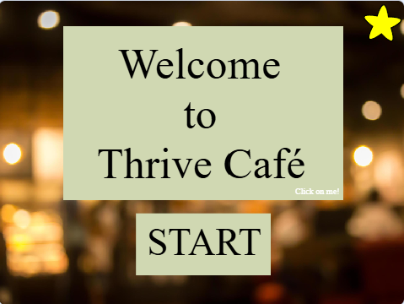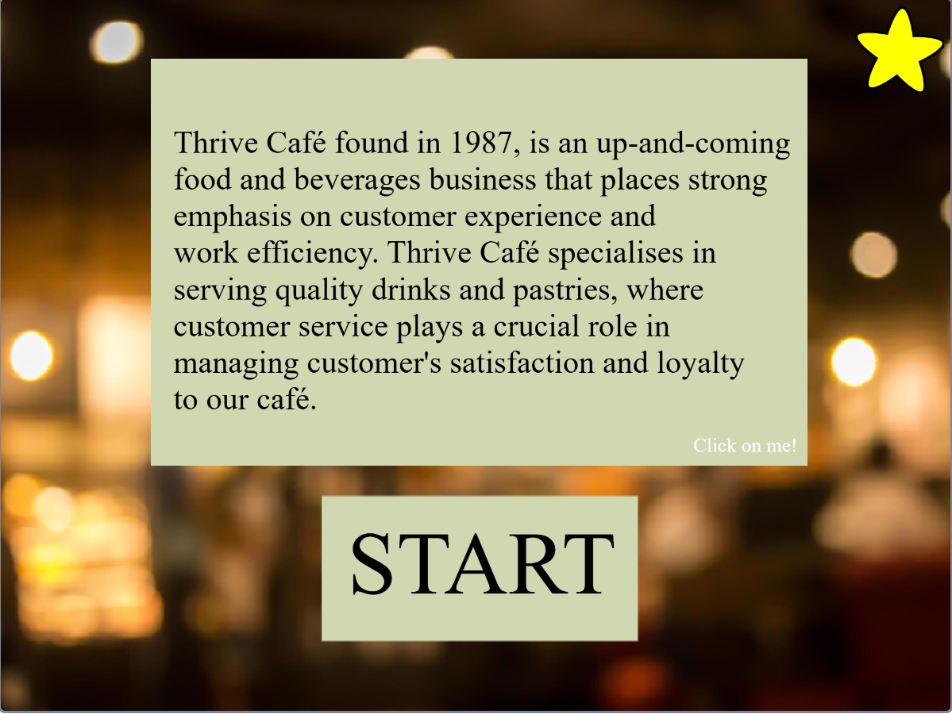

*Figure 21:Main menu*   *Figure 22: Card flipped around , introducing the caf*é

When the users hover over the Start button the words will turn white, and when the button is clicked it will direct users to the game introduction page that provides a quick overview of the game. The back button at the bottom left corner will allow users to go back to the main menu allowing them to read the introduction of Thrive Café again, and when users are ready

They can click on the next button bringing them to the next page.

 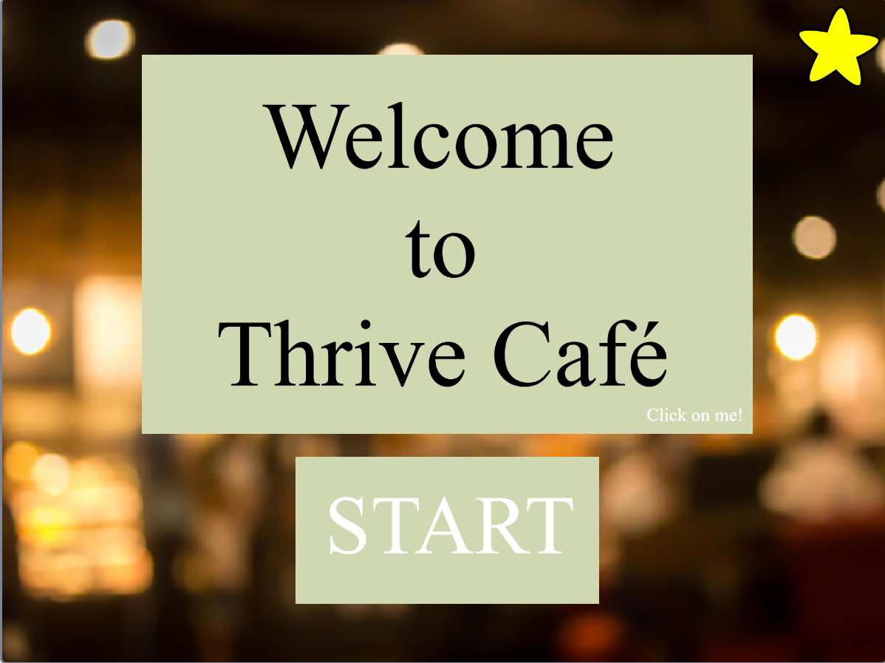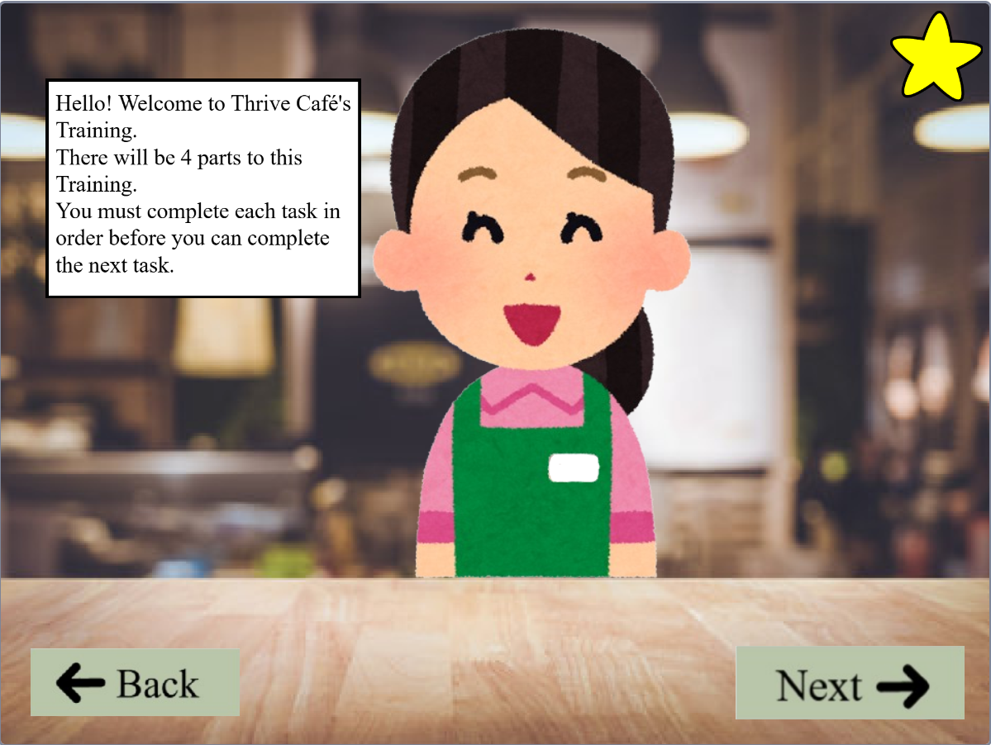 *Figure 23: User hovering over the start button Figure 24: Game introduction*

After users click the next button, the page will switch over to a page with jars. The jars represent tasks which are unlocked and need to be completed while the red jars are jars which need to be unlocked by doing the tastks before them. If users click on to the yellow jars a pop up will appear allowing them to start on the task.

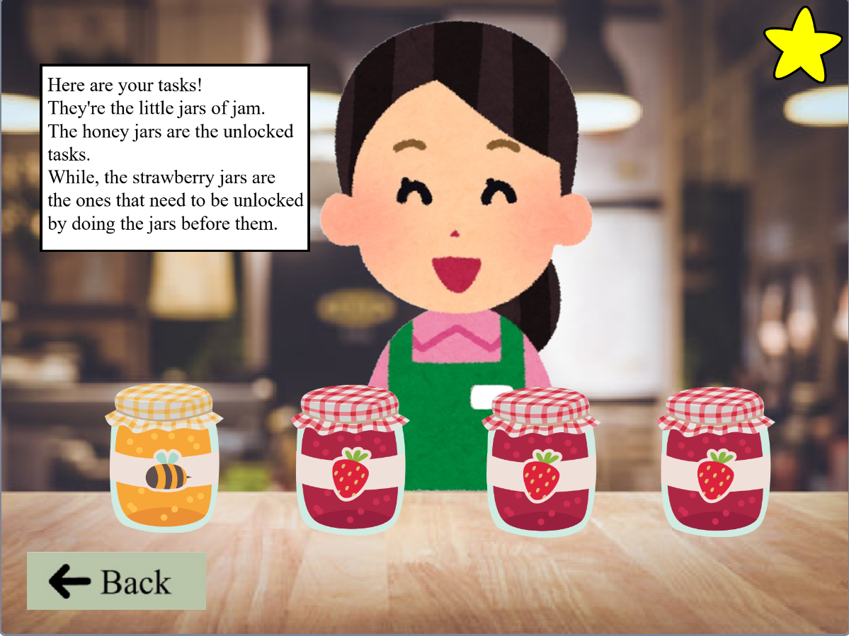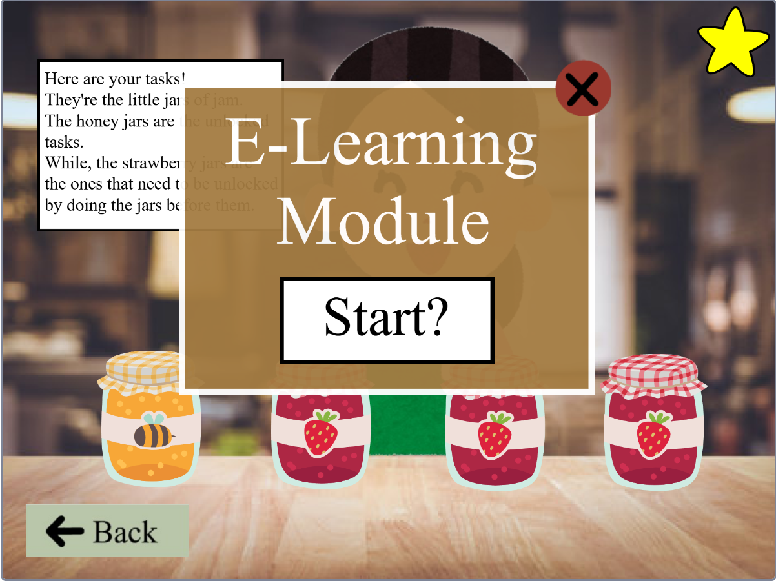 *Figure 24: Page with the jars representing the tasks*  *Figure 25: Pop-up that shows when yellow jar is clicked*

If users try to do the red jars without completing the tasks before them no pop up will appear but instead a prompt telling the user to do the task before it will appear instead. After completing the task from the jar before it, the red jar after that will turn yellow allowing users to start doing the task.

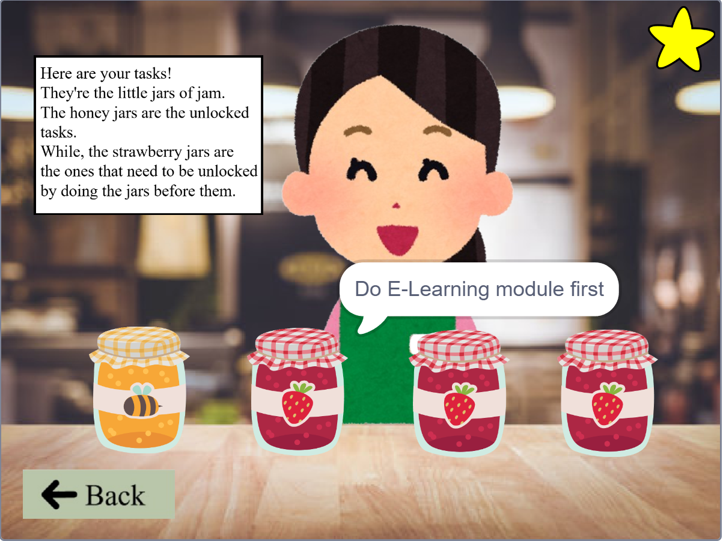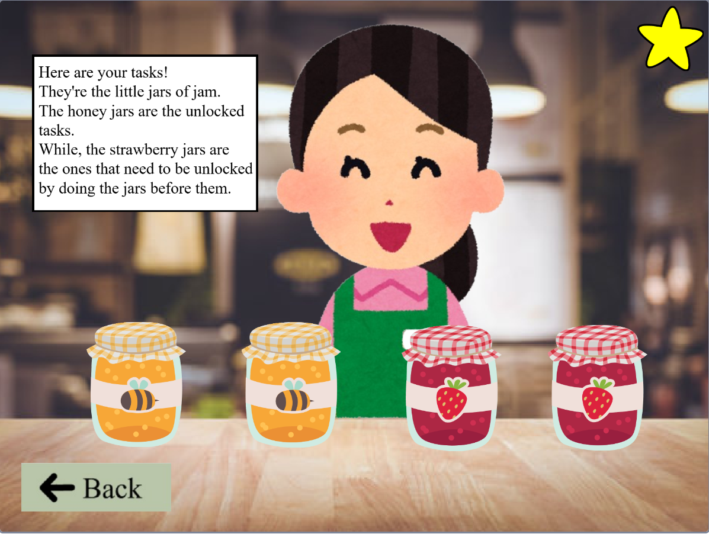

*Figure 26: Prompt coming up if jar before it is not done*  *Figure 27: Jar unlocked when jar before it is completed*

The star at the top right which is found in only the main menu, instructions, and jar pages allow users to rate their experience of the game and when the submit button is pressed. It will thank users for rating the game.

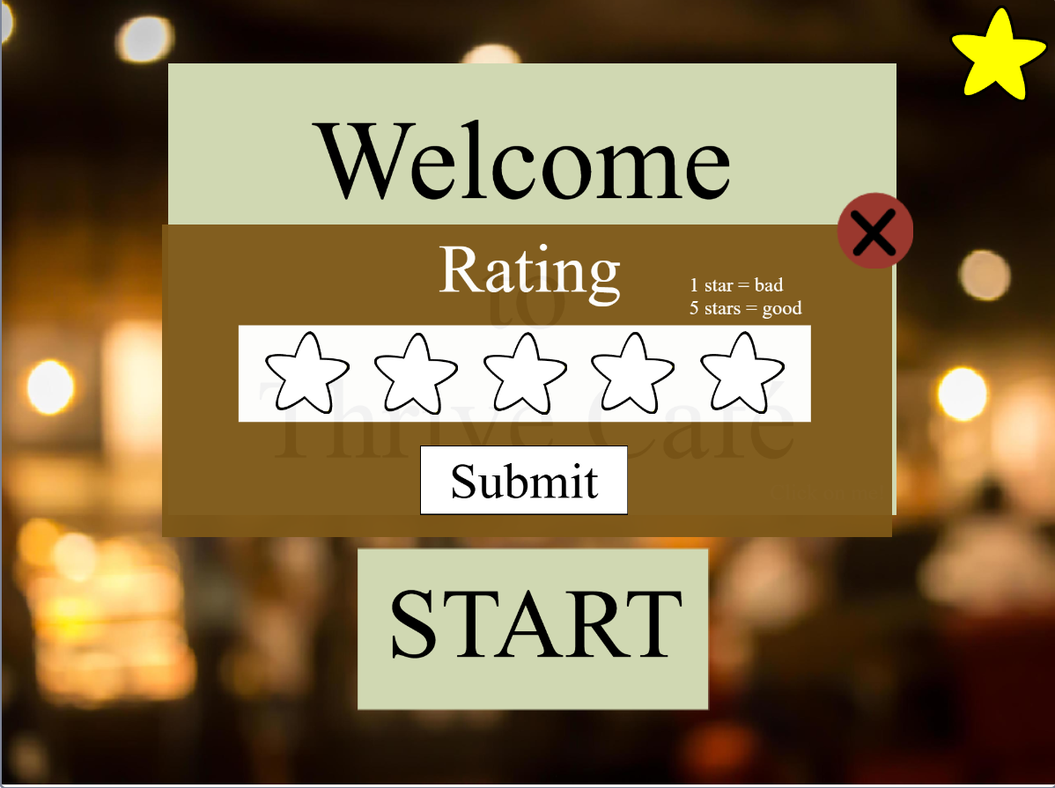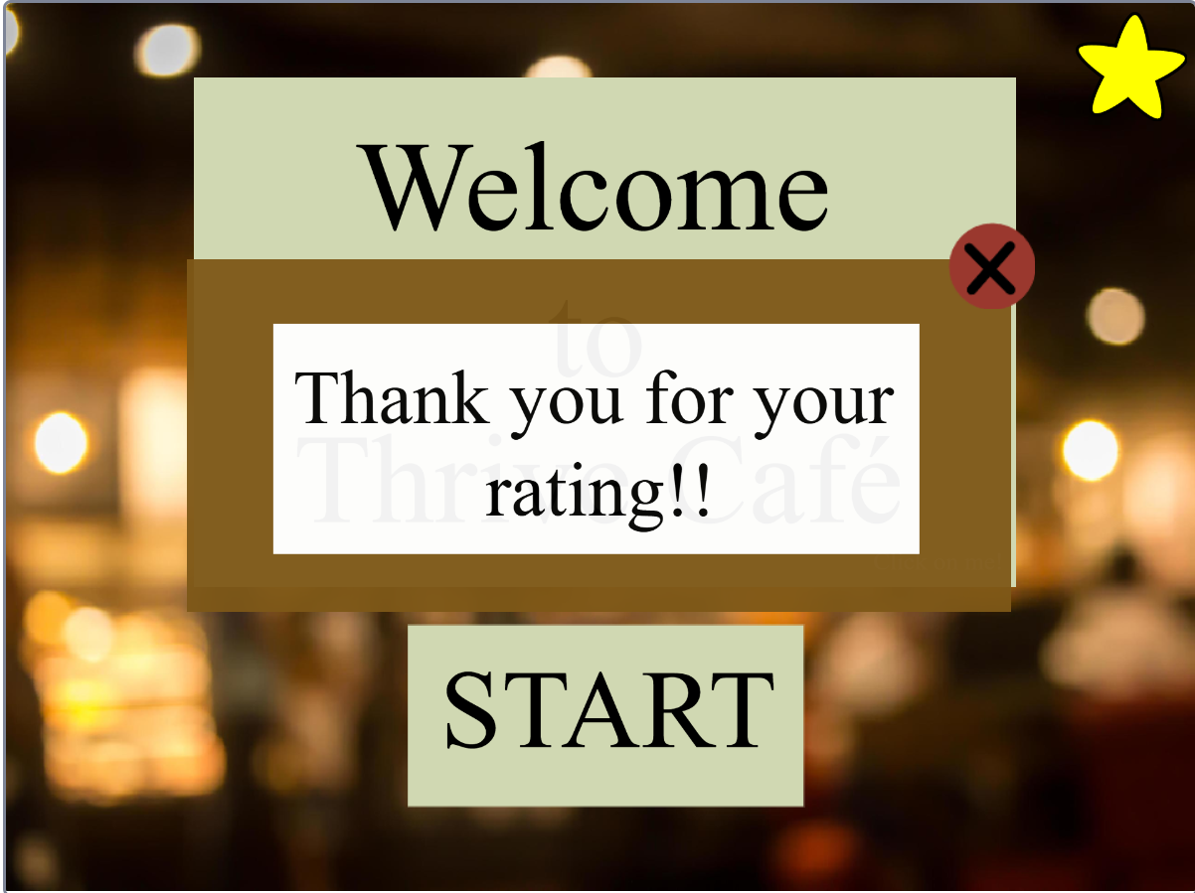

1. **Simulation Game (Venise)**

When users enter the simulation game module, they are first brought to a menu page that shows three buttons, each leading to either new game, controls or back to the homepage. When clicking new game, user will be directed to the selection page where they can choose to read the brief guide first or to start working.

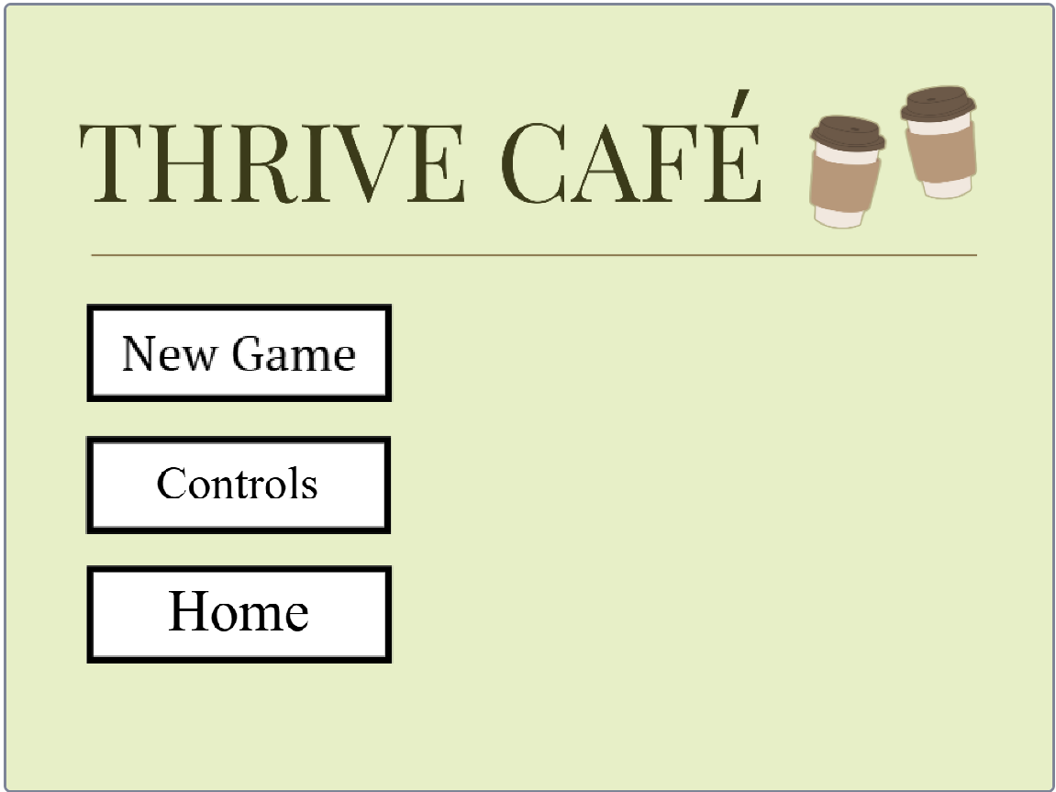 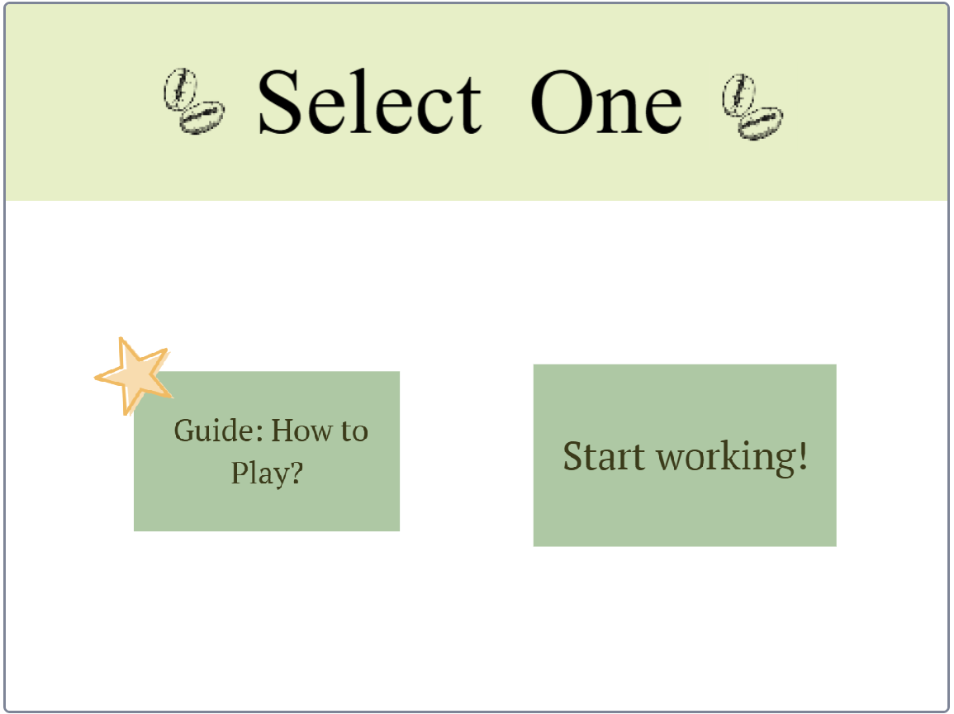

Controls button leads user to the controls page, where they can find how to navigate through. Guide page shows the general overview of what user needs to do in the simulation games

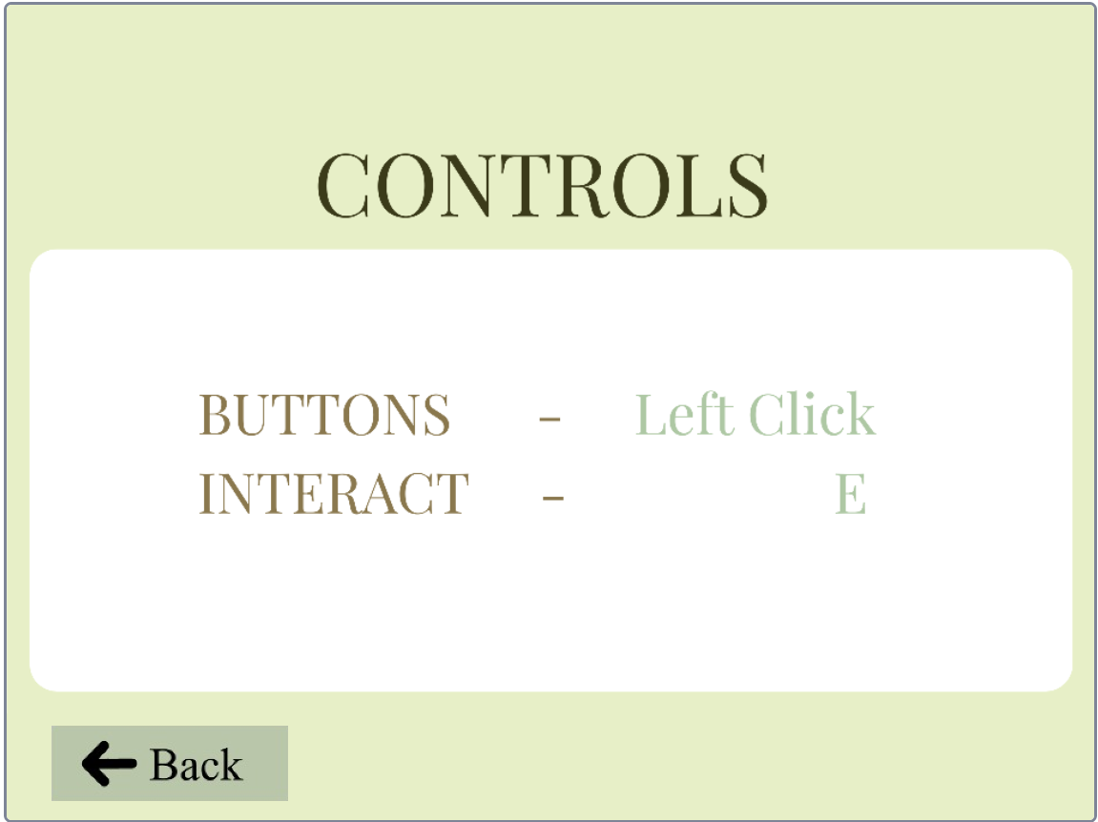 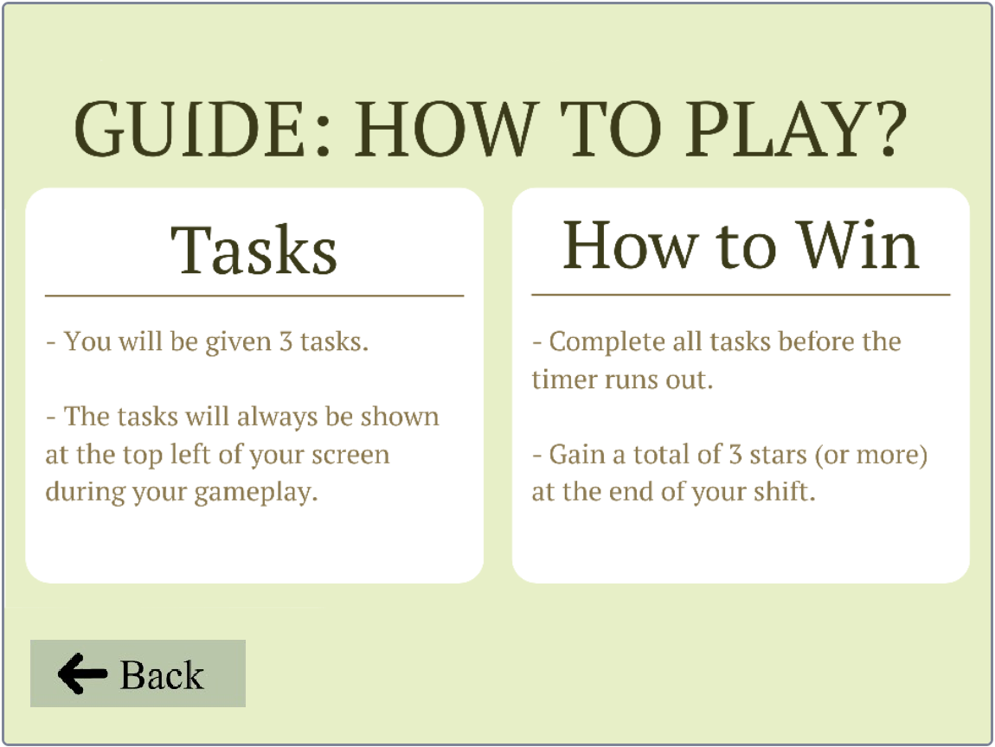

When user selects the “Start working!” button, they will be sent to the “What to do” page. In this page, they get a more in-depth overview of what they need to complete. Afterwards, user will be required to click any of the white boxes if they need a guide on what each box does. 

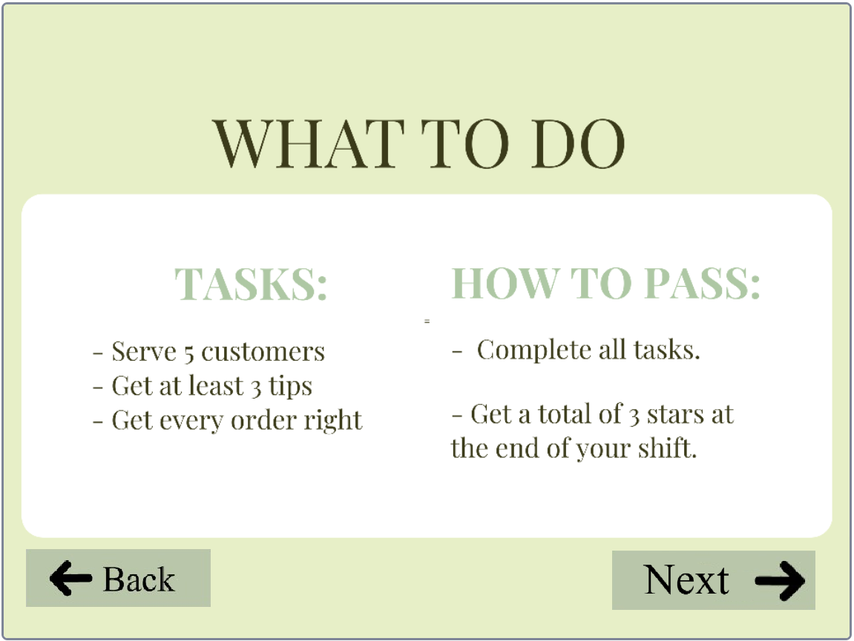 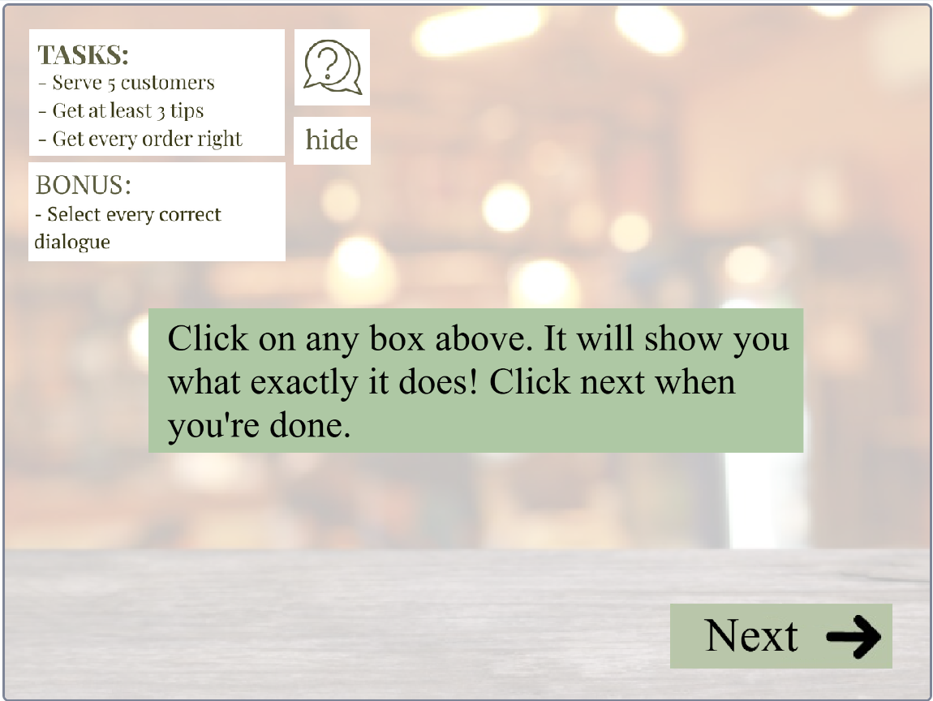

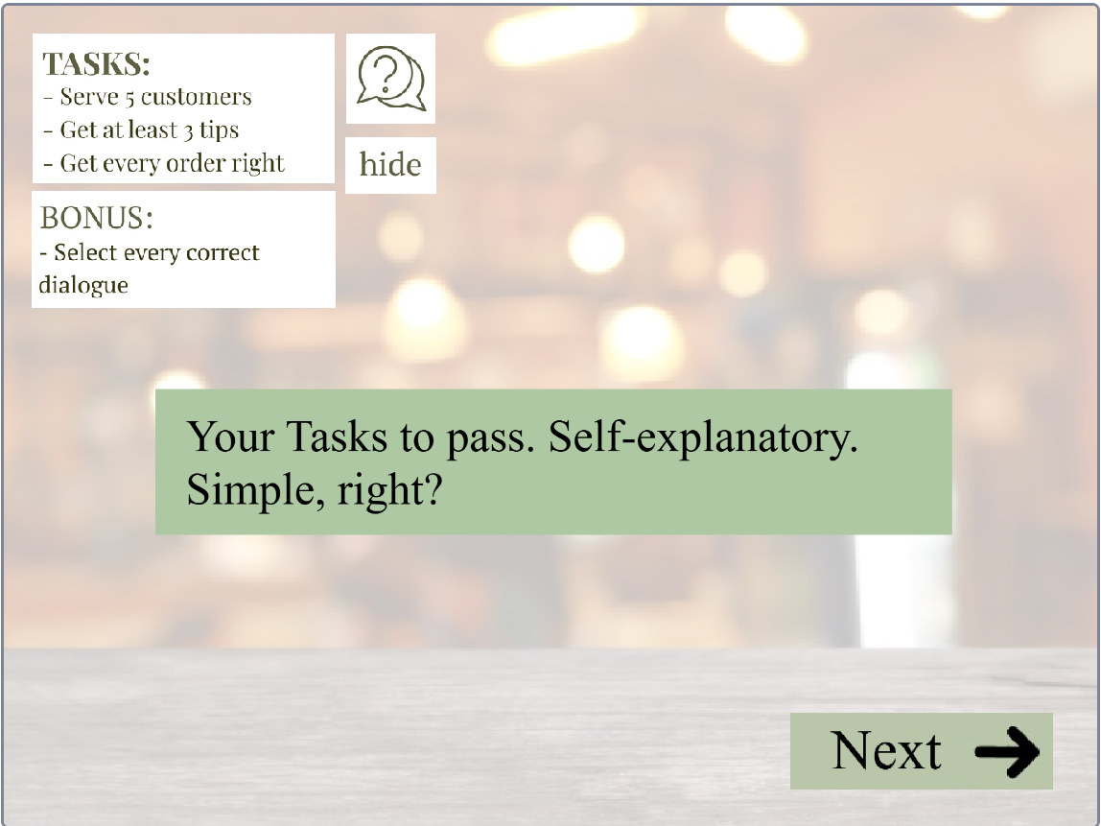 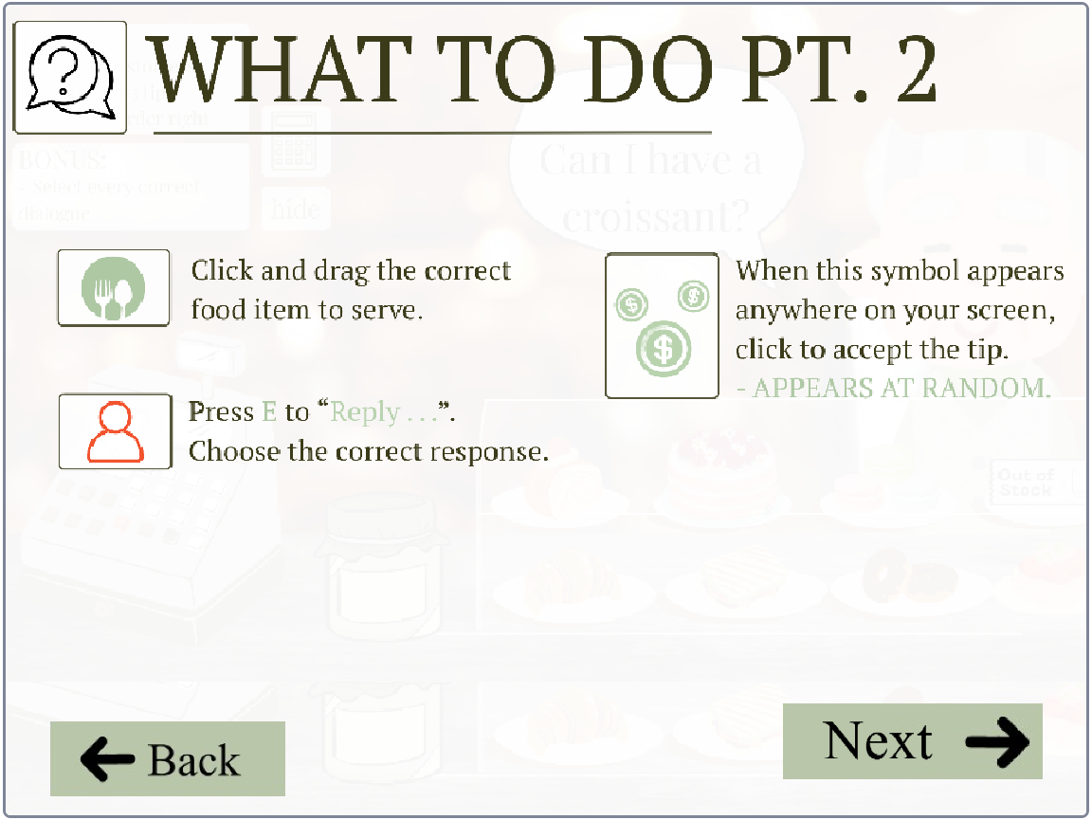

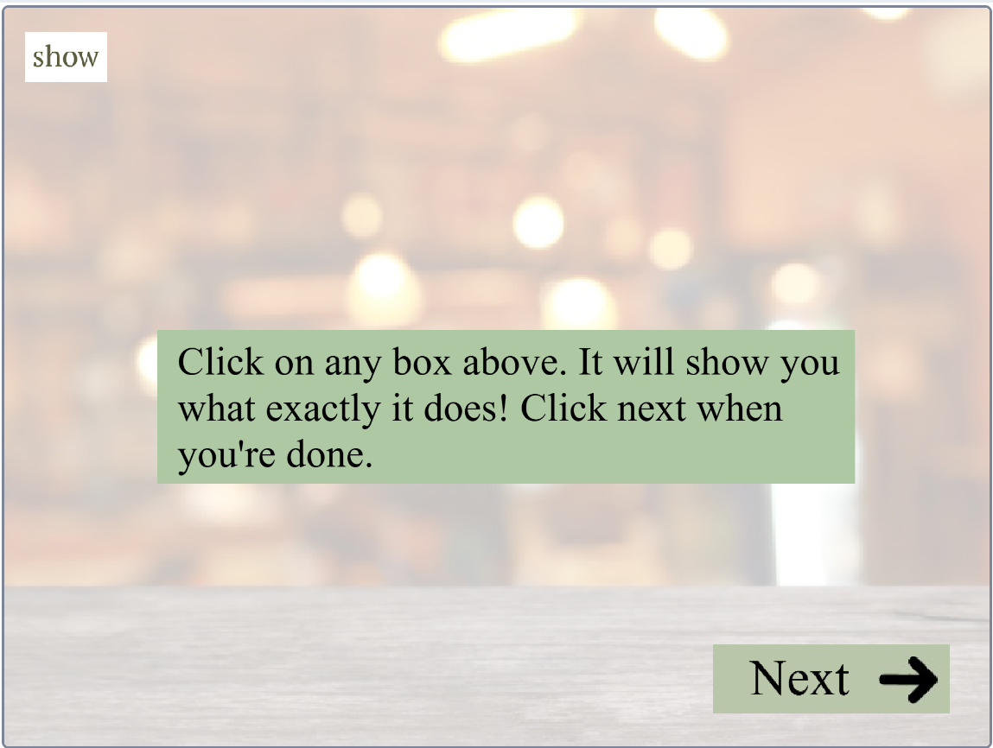

When users click “Next”, they will be sent to the main game page. Here, user will be able to interact with customers. All the food items are draggable. However, they need to reply first. On the left side, there is a text that says, “Press E to Reply”. Users are required to press “E” on their keyboard and pick the right dialogue option before dragging the corresponding food item to the customer.

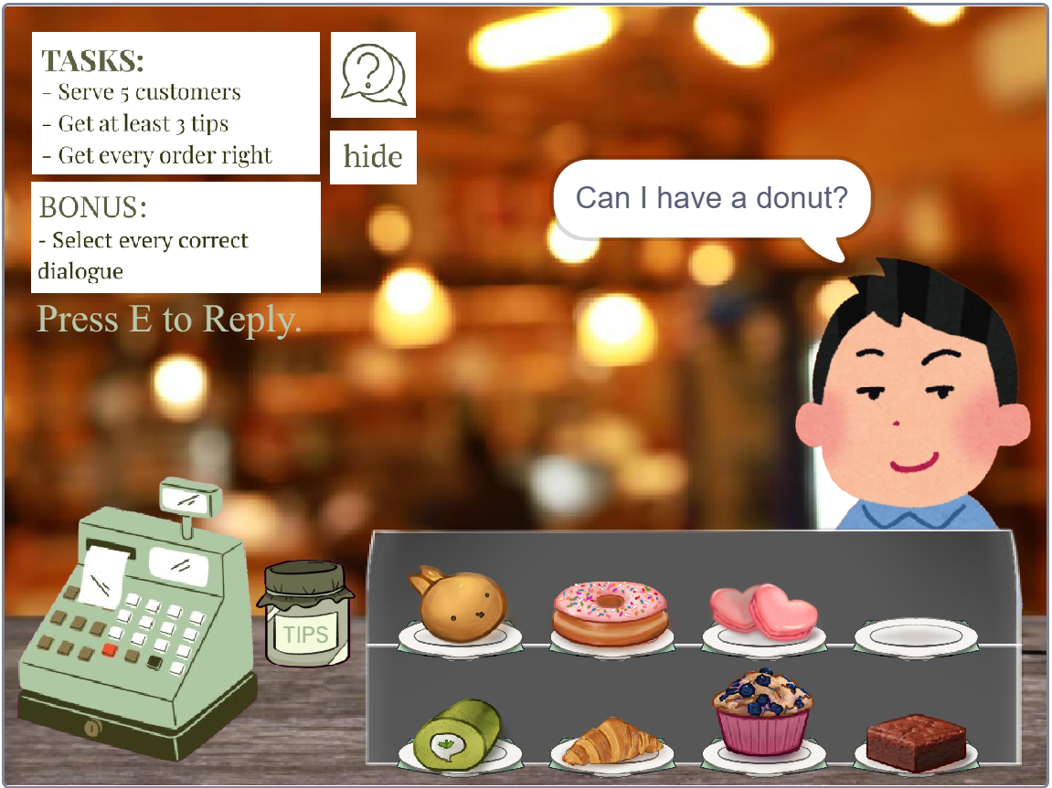 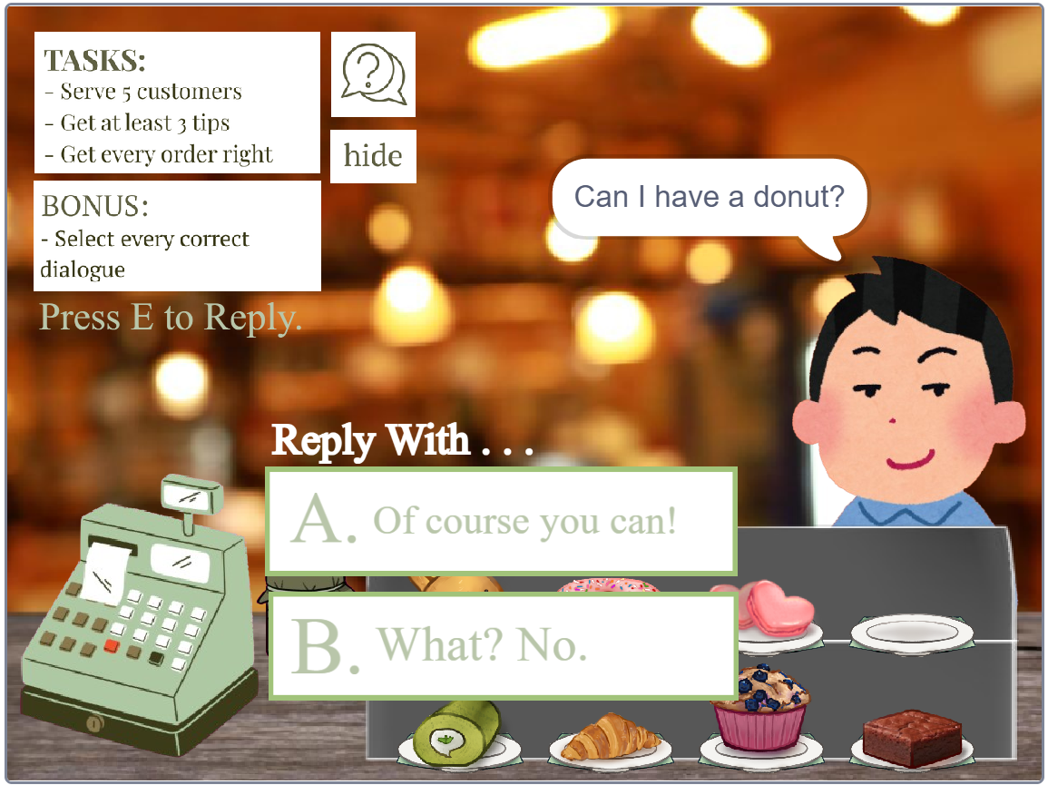

After giving the food to the customer, the food will disappear as if handing the item to the customer. When the next customer comes along, the food item given to the last customer appears again. For the next few customers, this function repeats each time.

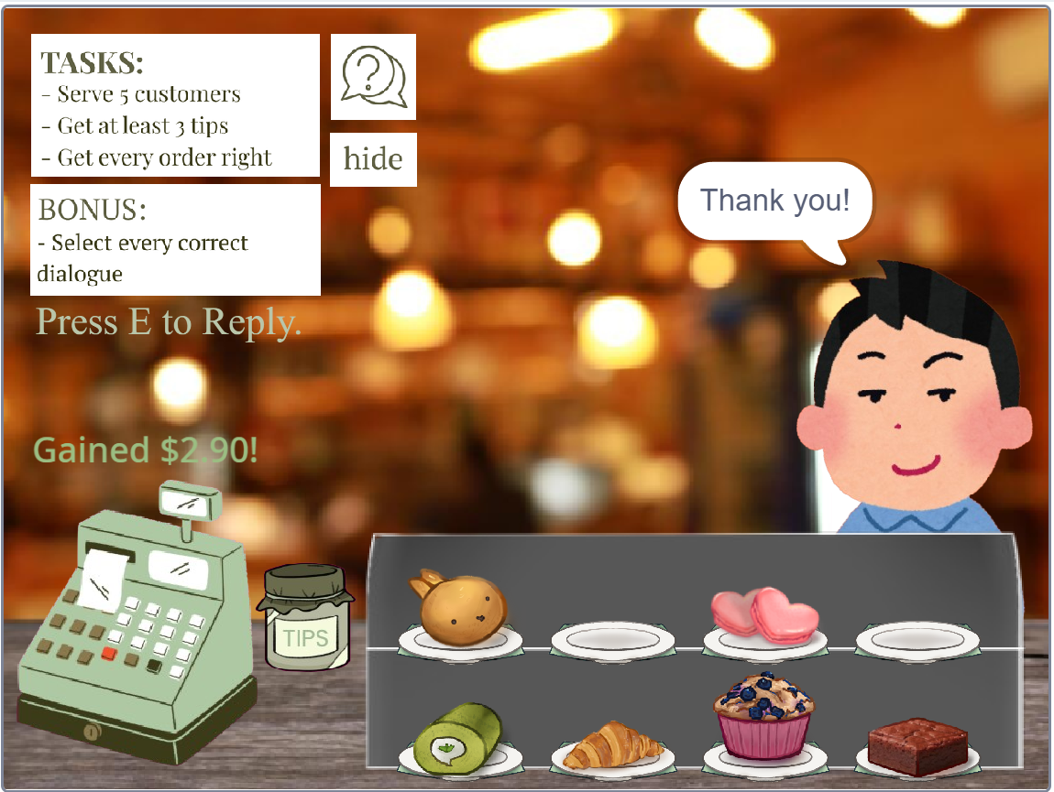 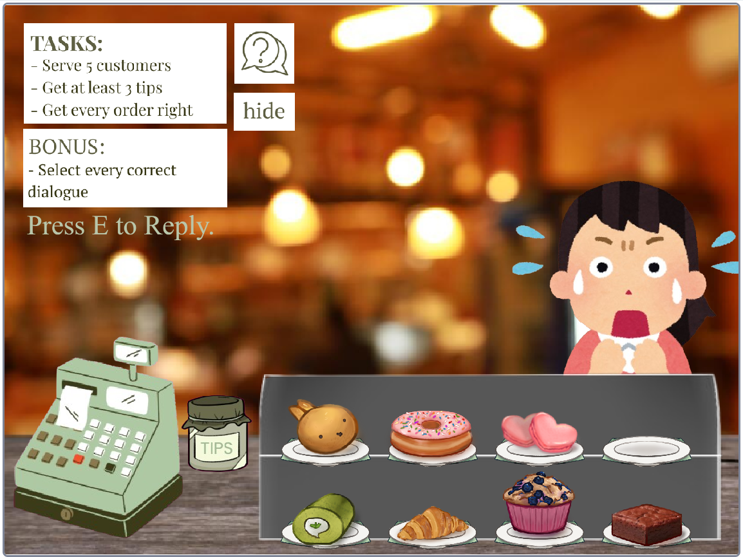

When the food is successfully given to the customer, there will be a pop-up on top of the cashier. The pop-up shows the amount they’ve paid. Another fun function is the tip. When the 3 dollars sign symbol appears at any random time, user can click on it to receive. At the end of the game, it will be counted in the score.

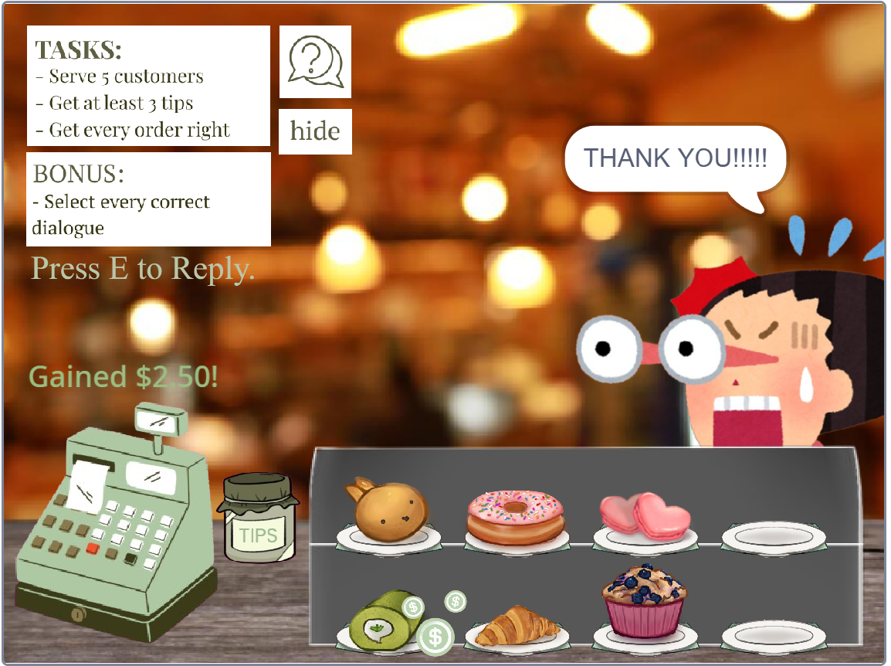 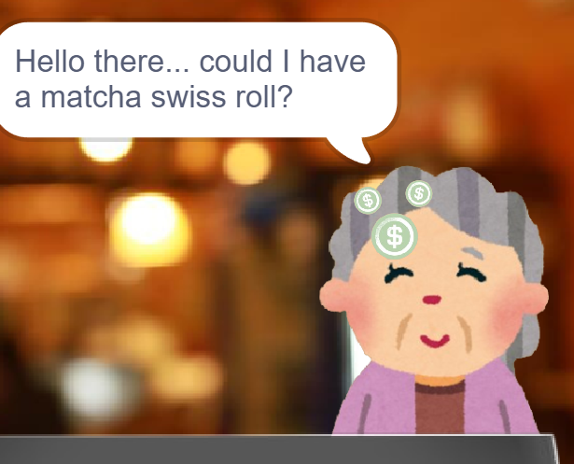

If the user selects the wrong dialogue, the customer will give a negative response and leave. This affects the number of stars they receive at the end of the simulation game.

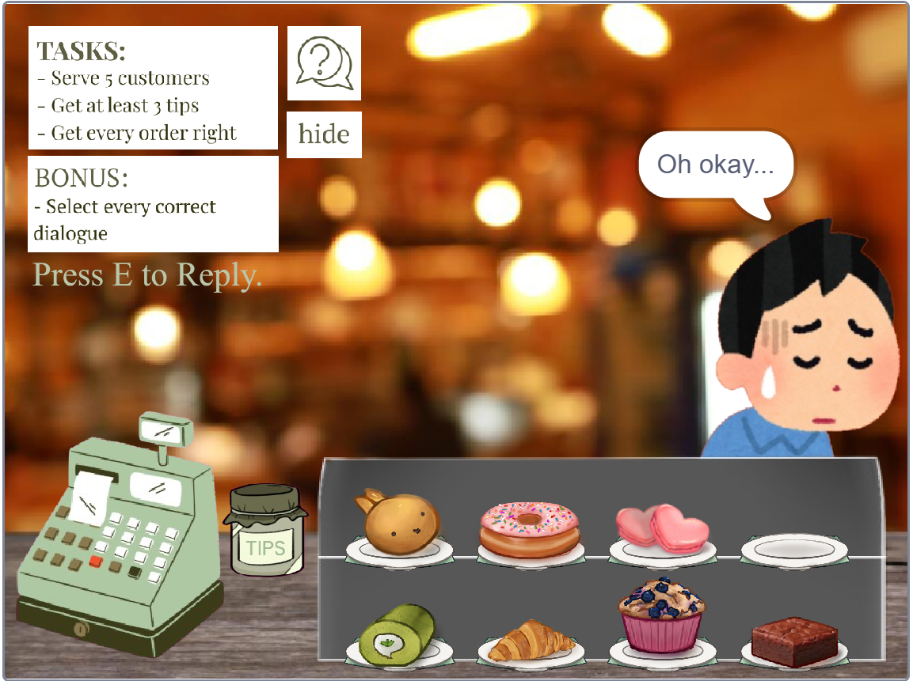 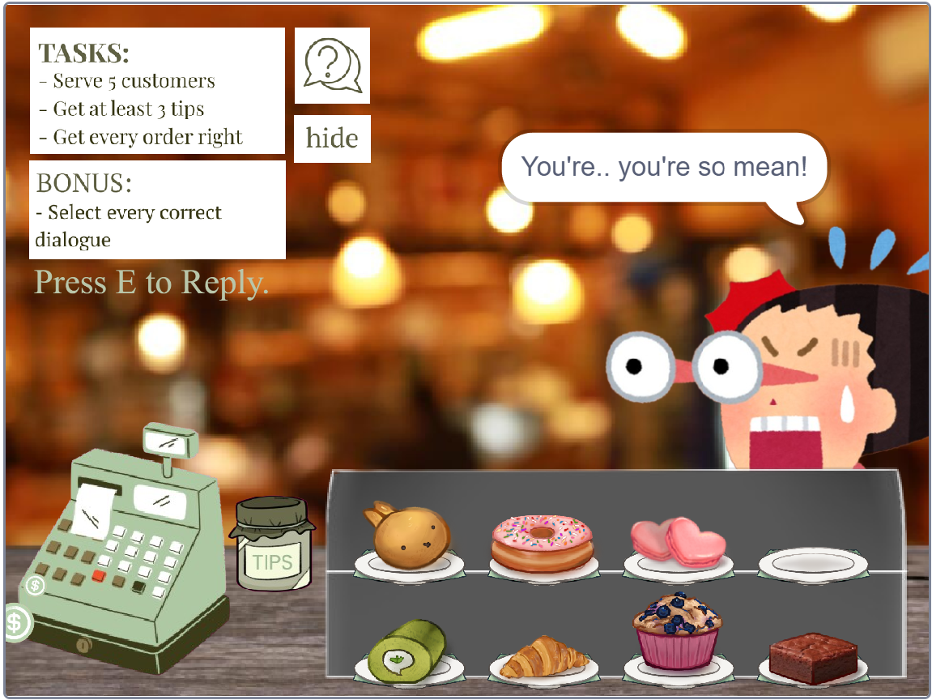

At the end of the game, user will be able to see how much customers they have served, how many tips they receive, and how many orders they got right. For each task they complete, they gain a yellow star. As for the bonus section, if users select the correct dialogue all 5 times, they will gain a blue star. User will also be given the option to play again or go back to the main menu, which is the main navigation menu.

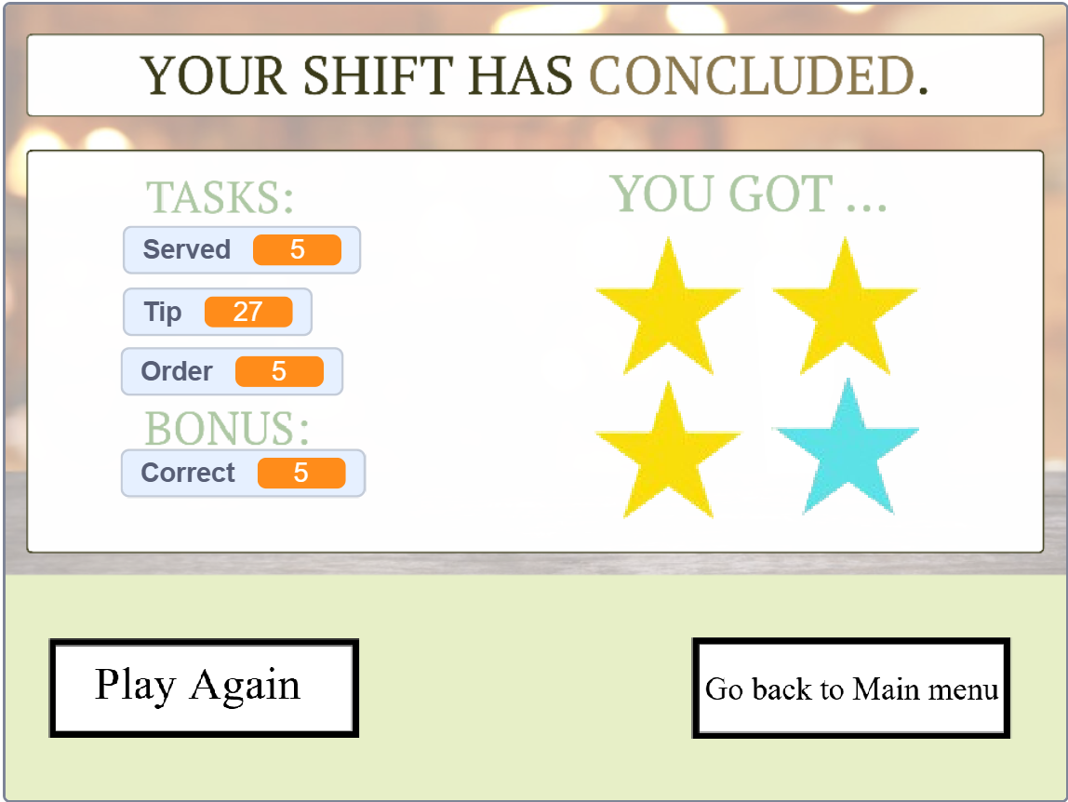

1. **E-learning Module (Kaede)**

When users enter the e-learning module, they are first brought to a content page that introduces the Thrive Café training. A guide sprite will then say a welcome message and directs users to click the grey information icon at the top-right corner, which will later lead to the instruction page explaining how to navigate the module.

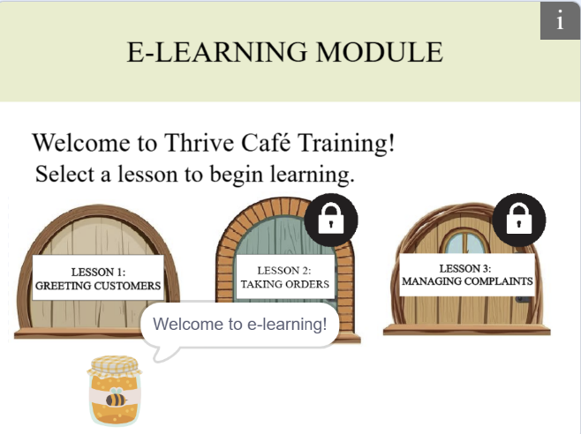 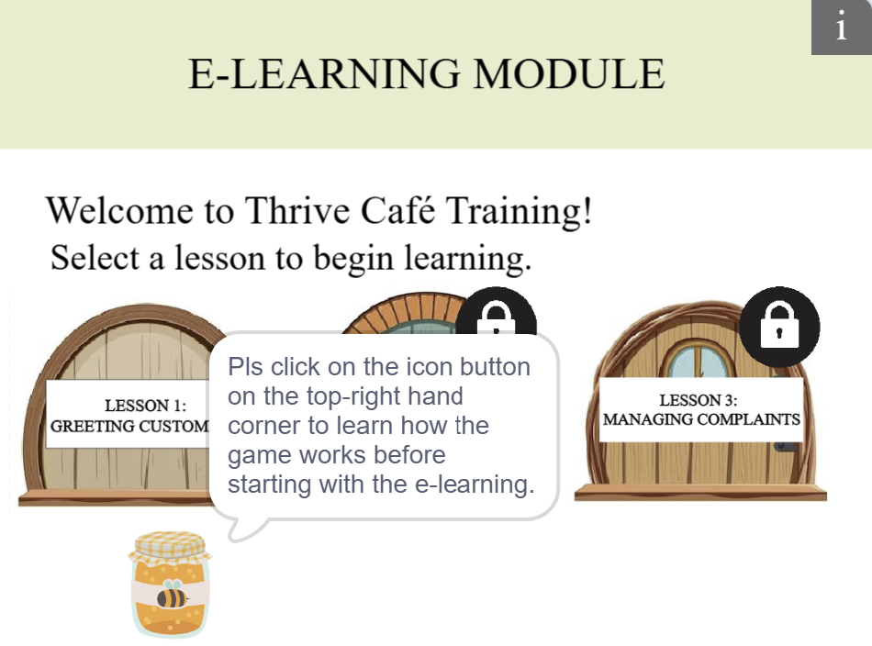

Figure 1:Content page with welcome message Figure 2: Content page with direction to instruction page

After clicking into the instruction icon, users are directed to the instruction page that explains the things how to navigate around the e-learning, like clicking the arrow keys to move the sprite, pressing on the ‘A’ key to enter each Lesson, pressing the [space] key to get into each sub Lesson, and clicking on the ‘next’ button to go to the next sub-lesson or clicking on the ‘back to hub’ button to go back to the content page. During demonstration, movement is only enabled when each instruction has been explained, ensuring that users do not proceed without knowing the controls. However, for demonstration purposes, the 'Next’ button that appeared on the sub-lesson 1 demonstration page returns them to the content page instead of the next sub-lesson.

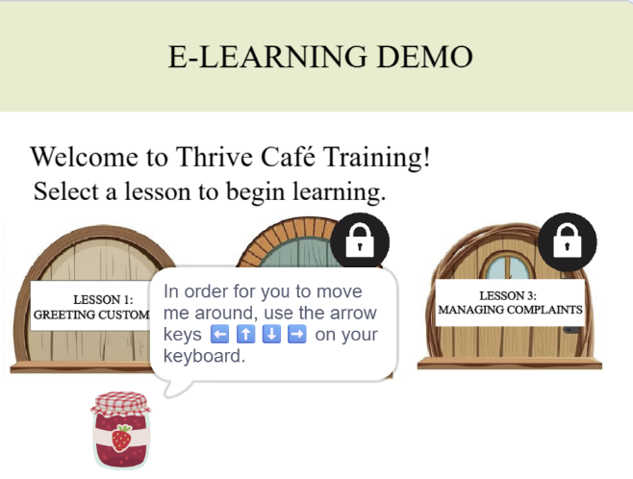 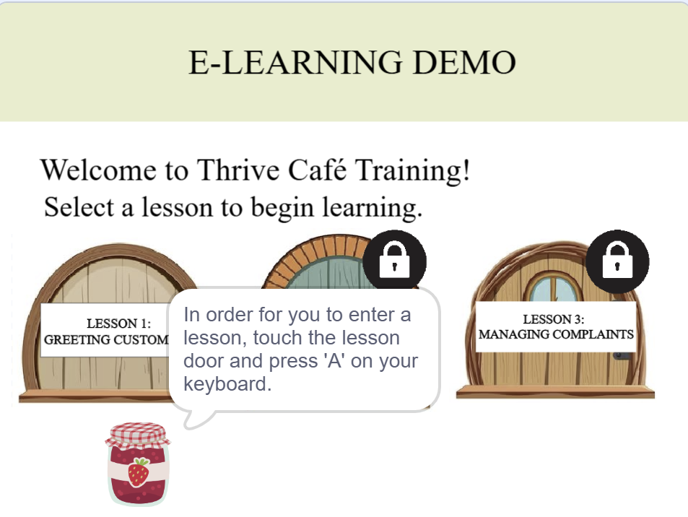

*Figure 3: Instruction page with instructions on how to move Figure 4: Instruction page with instructions on how to go into around a sub-lesson*

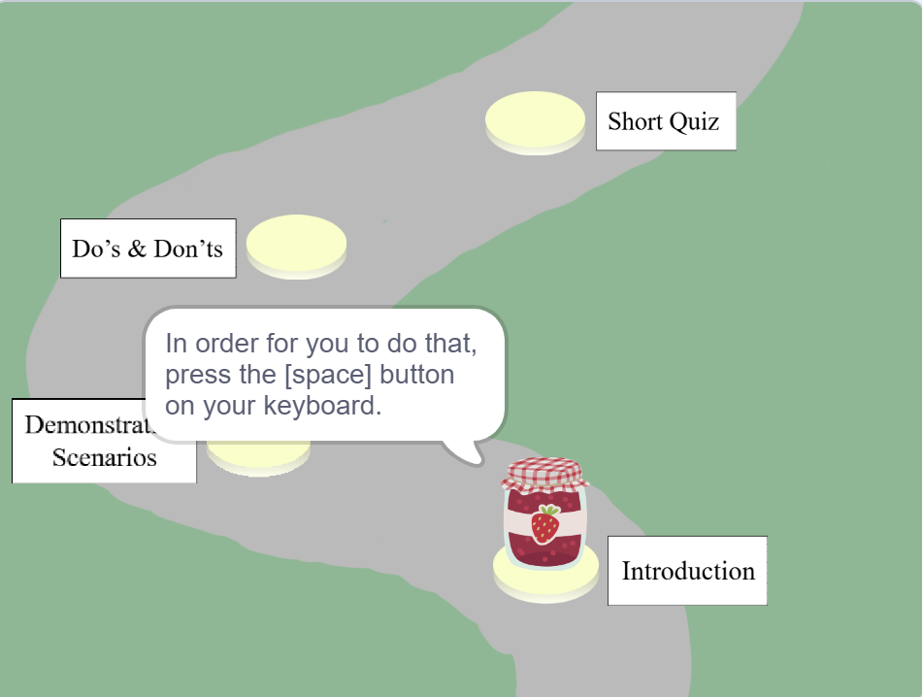 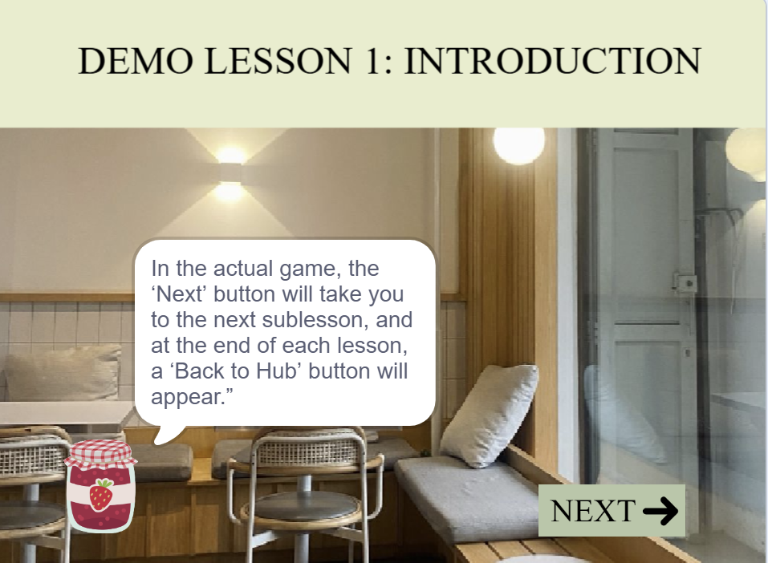

*Figure 5: Lesson1 demo with instructions on how to get Figure 7: Sub-lesson 1 demo with instructions on ow to move*

*into a sub-lesson on to the next sub-lesson*

After clicking on the next button in “Demo Lesson 1: Introduction”, it will lead users back to the content main earlier on, leaving the demonstrative section and entering the main module.

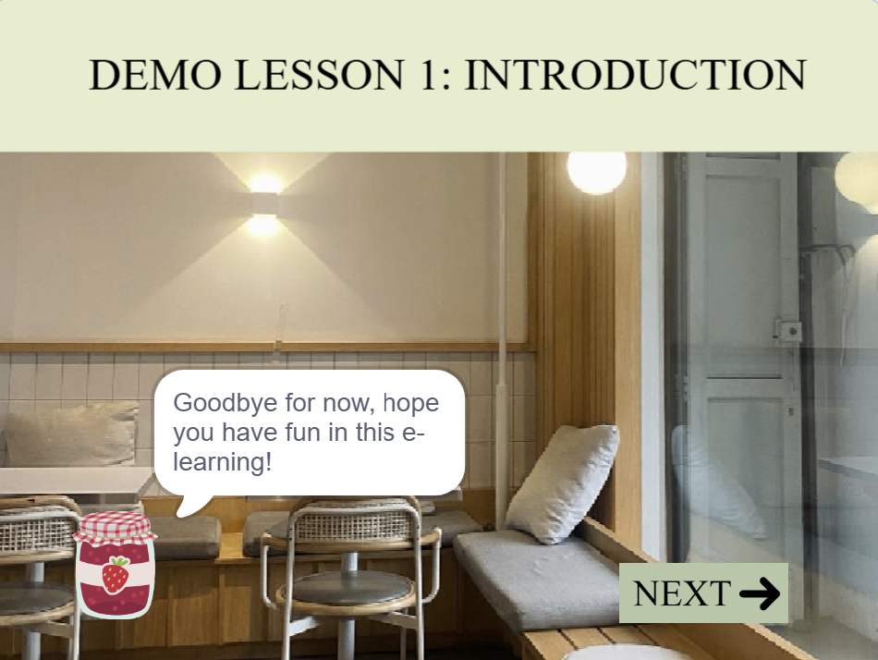 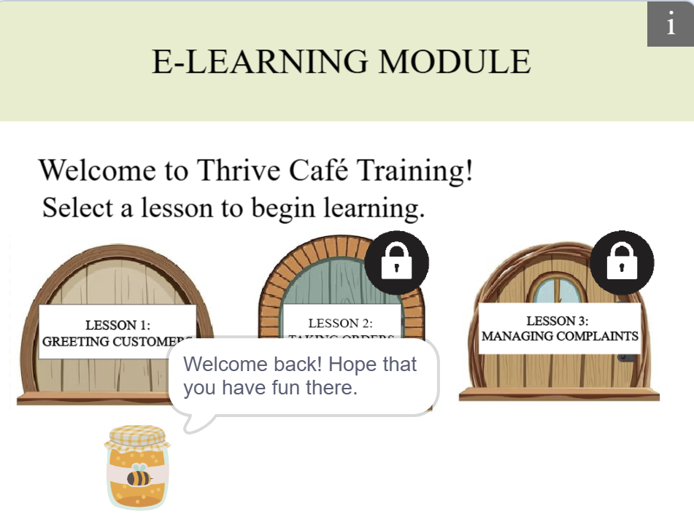

*Figure 7: Sub-lesson 1 demo with instructions on how to Figure 8: Content page with welcome back message*

*move on to the next sub-lesson*

This is where the actual e-learning begins. When the user touches the door for Lesson 1 and presses the ‘A’ key, they are directed into Lesson 1, where the jar sprite will land on the rock labelled “Introduction”. To ensure a more structured learning flow, users are unable to enter subsequent Lessons unless the previous Lesson has been completed entirely. This guides the users to complete the Lessons in a more organised and sequential manner.

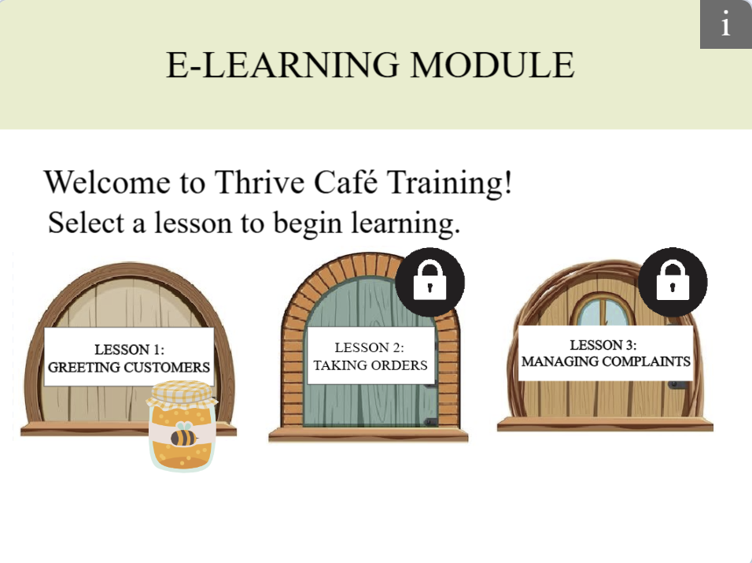 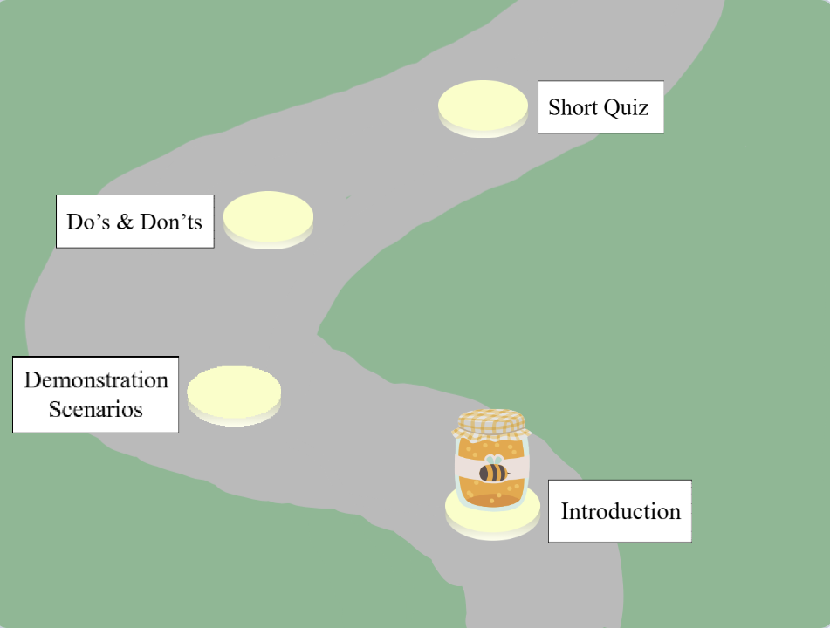

*Figure 9: Sprite touching Lesson door to enter Lesson Figure 10: Lesson 1 Lesson map upon entry*

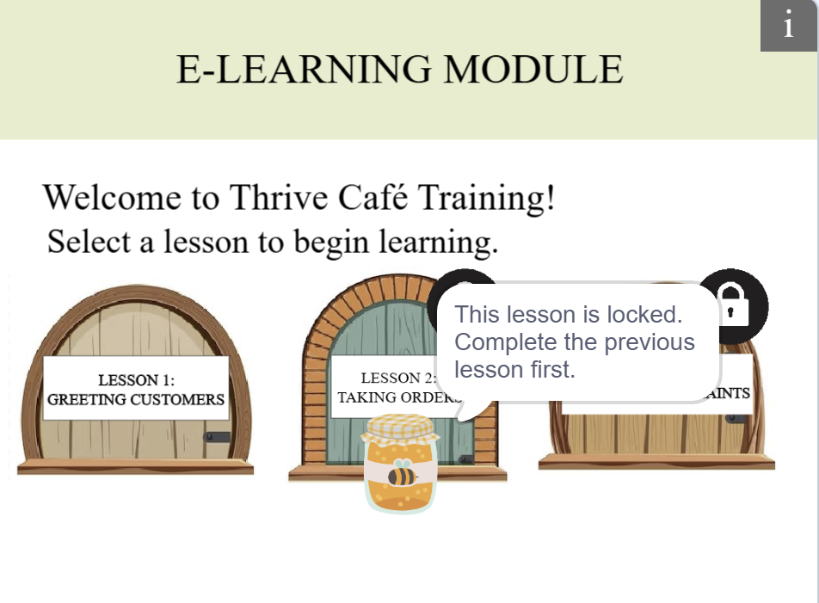 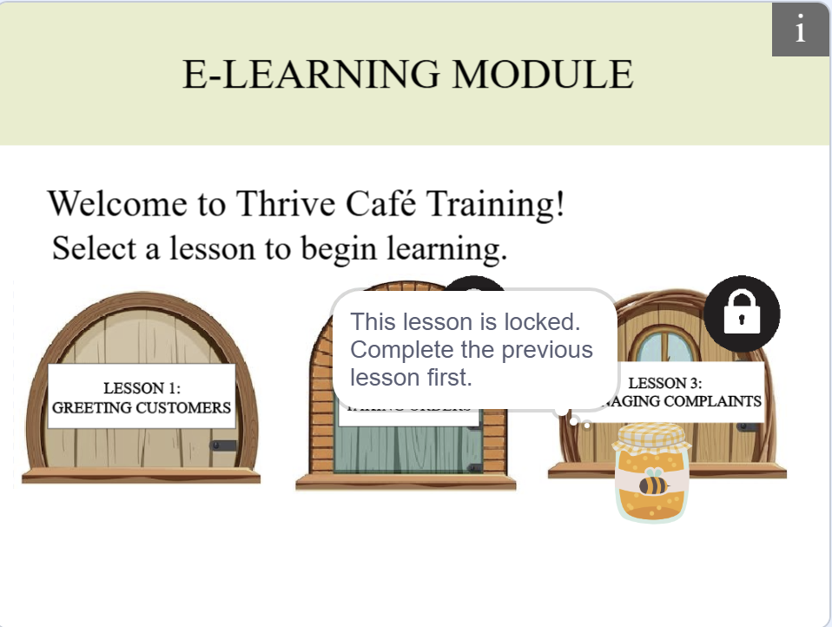

*Figure 11: Locked Lesson state for Lessons 2 Figure 12: Locked Lesson state for Lessons 3*

After the user has entered the Lesson, they are required to press the [space] key to access the sub-lesson. Upon completion of the sub-lesson, a ‘Next’ button appears, directing users to the next rock on the Lesson page.

 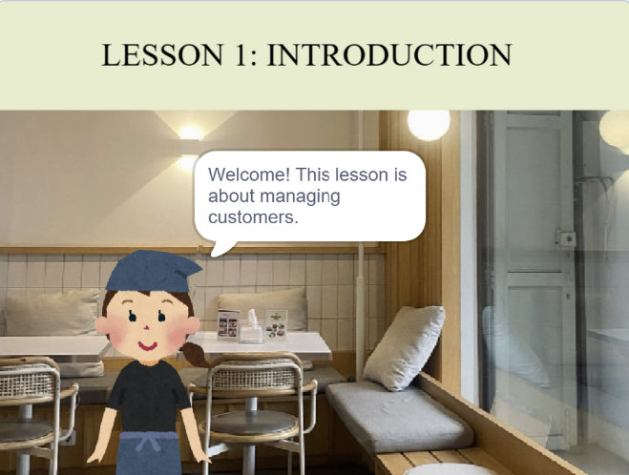

*Figure 13: Lesson 1 Lesson map upon entry Figure 14: Sub Lesson 1 upon entry*

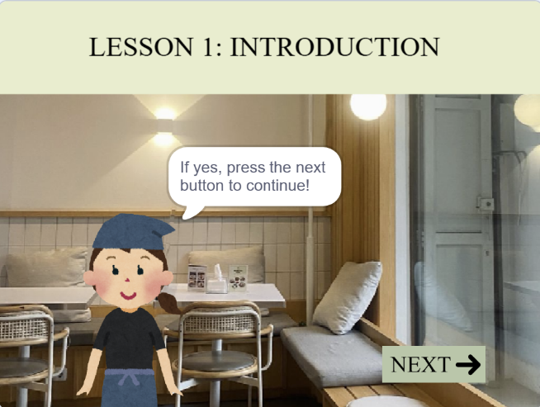 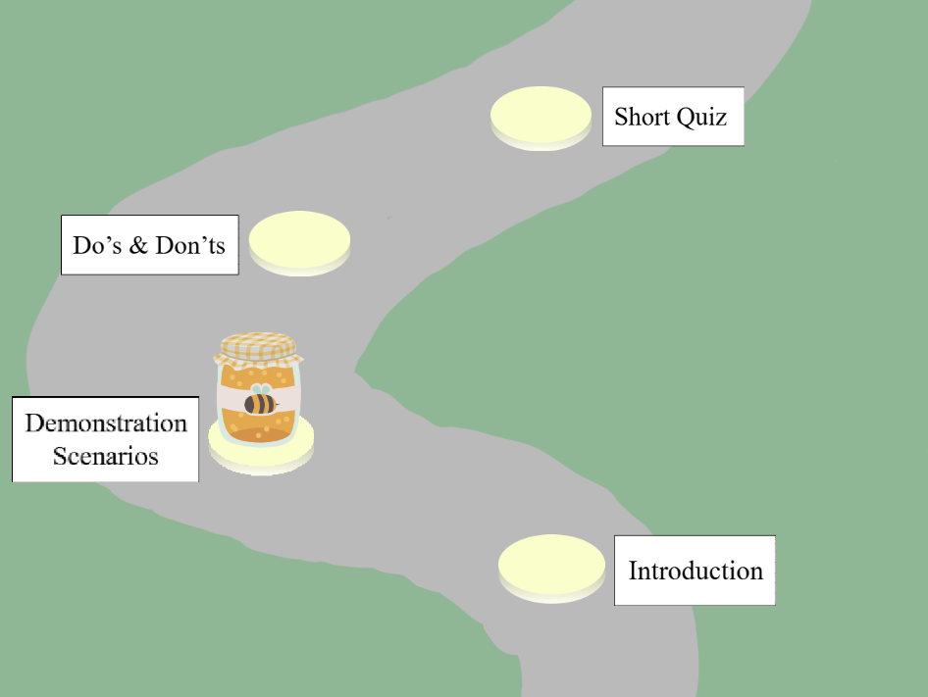

*Figure 15: ‘Next’ button to the next sub Lesson Figure 16: Sprite moved to sub Lesson 2*

After completing all sub-lessons in a Lesson, including the quiz, a “Back to Hub” button appears. By clicking it, it returns users back to the content page and unlocks the next Lesson for access. This process repeats for all 3 Lessons, ensuring that Lesson 2 can only be accessed after Lesson 1 is completed, and Lesson 3 can only be accessed after Lesson 2 is completed.

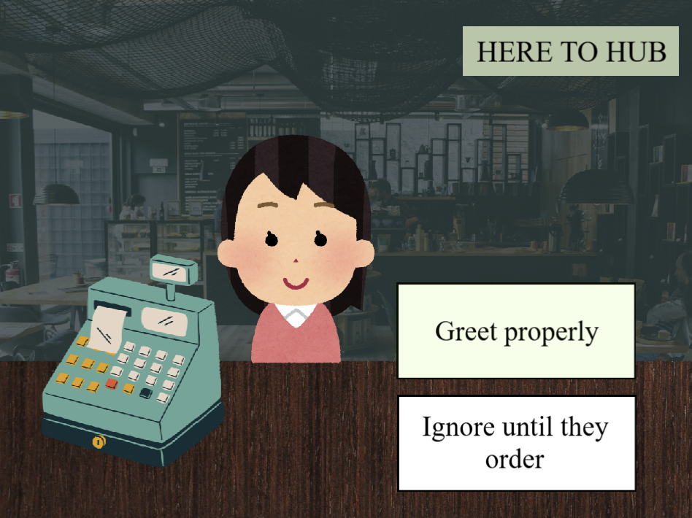 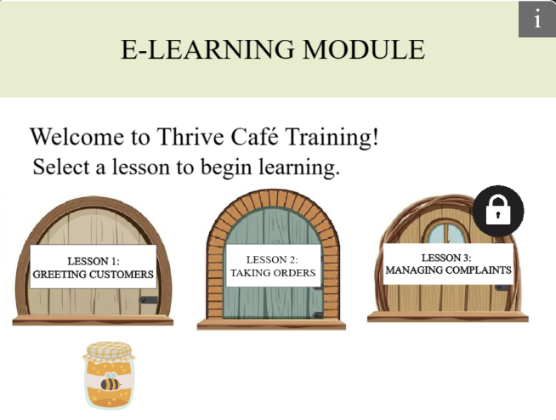

*Figure 17: Quiz Completion with “Back to Hub” Button Figure 18:* *Lesson 2 Unlocked After Lesson 1 Completion*

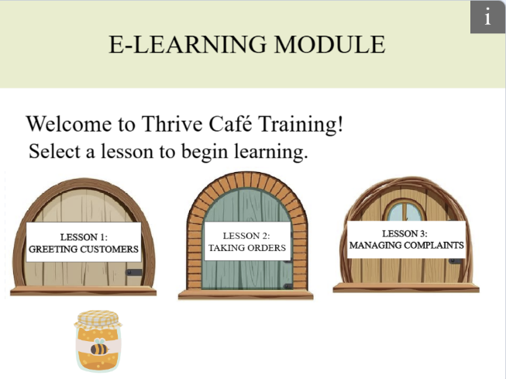

*Figure 19: Lesson 3 unlocked after lesson 2 completion*

After all 3 e-learning lessons have been completed, a ‘Home button appears, leading the users to back to the homepage, and the quiz module will then be unlocked. Once all lessons are completed for the first time, users are free to revisit any lesson as many times as needed, allowing them to review the content and become fully familiar with the learning materials, so that they will be able to answer the quiz and pass it smoothly.

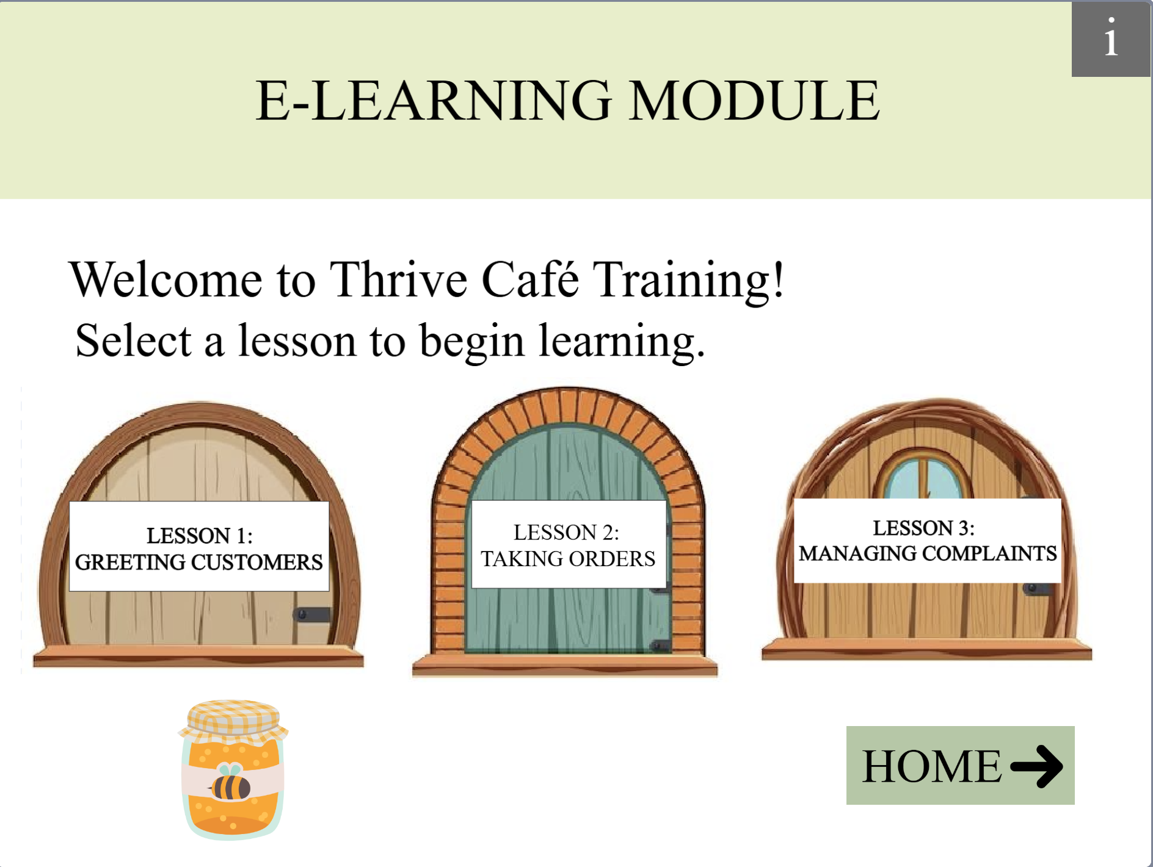

*Figure 20: Next button appearing after completion of all 3 lessons*

1. **Quiz Module (Jin Hui)**

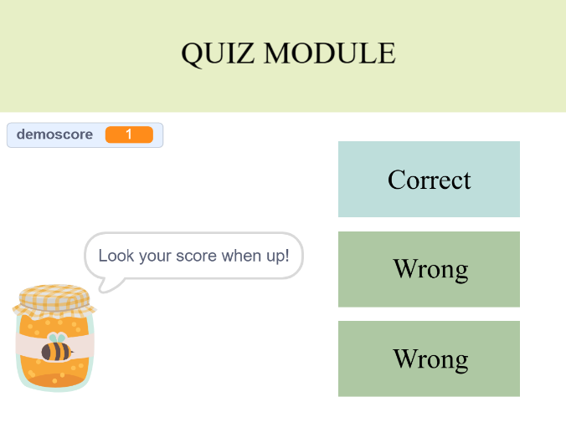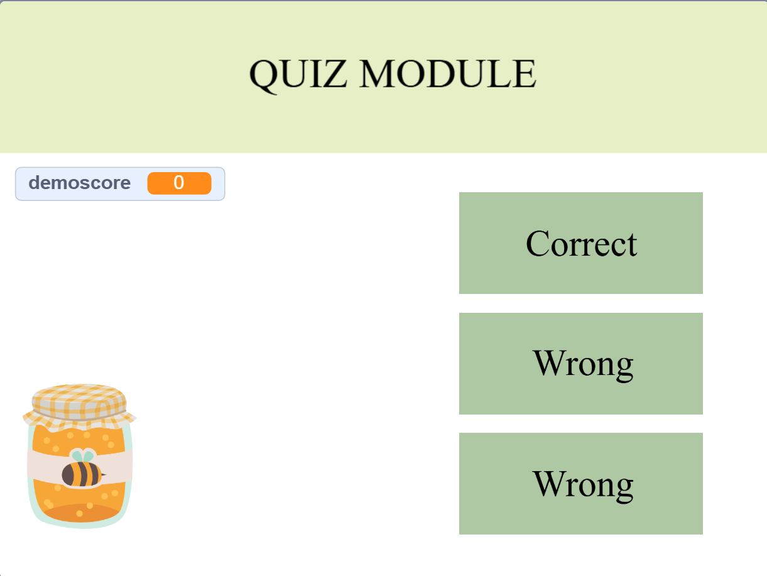

This is the demonstration section where it teaches users what happens when they click the right answer. When the user clicks the “Correct” option, the “demoscore” goes up by 1 and the option changes colour to blue, indicating that the user has gotten 1 mark.

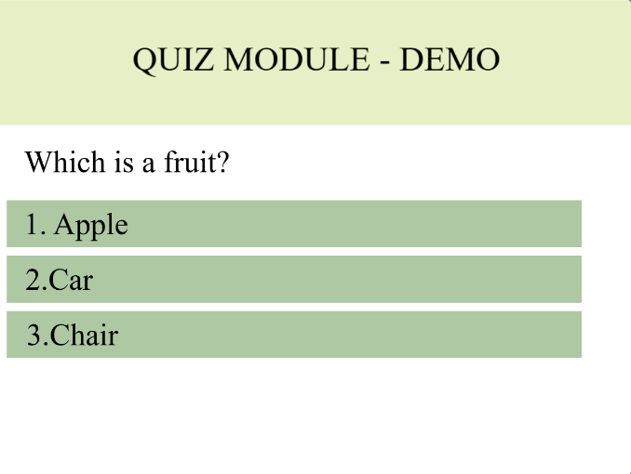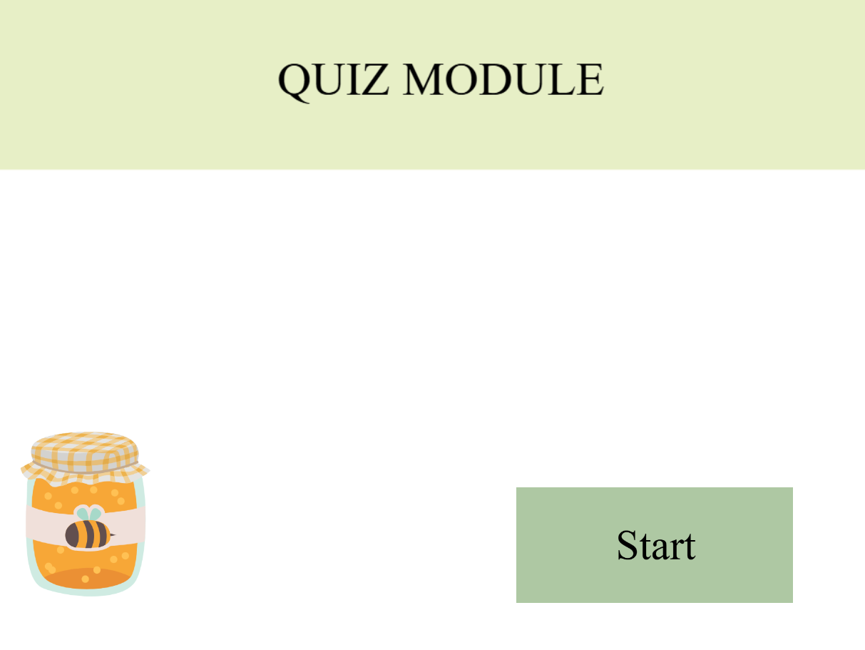

This is part of the demonstration section where when the user clicks on the “Start” option, it leads them to a demonstrative view of how the actual quiz will look like, how it functions.

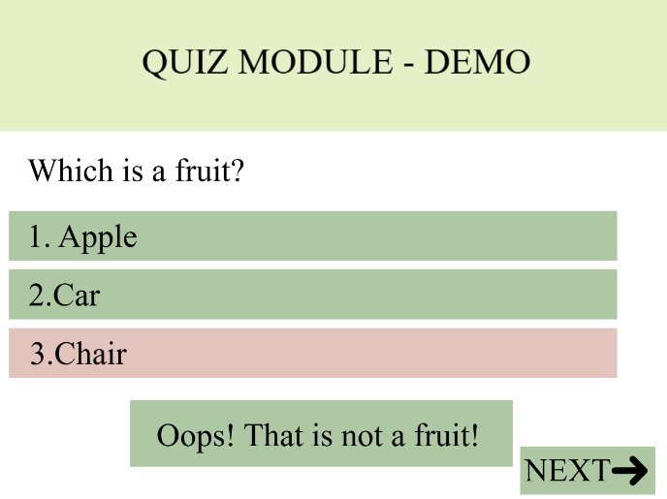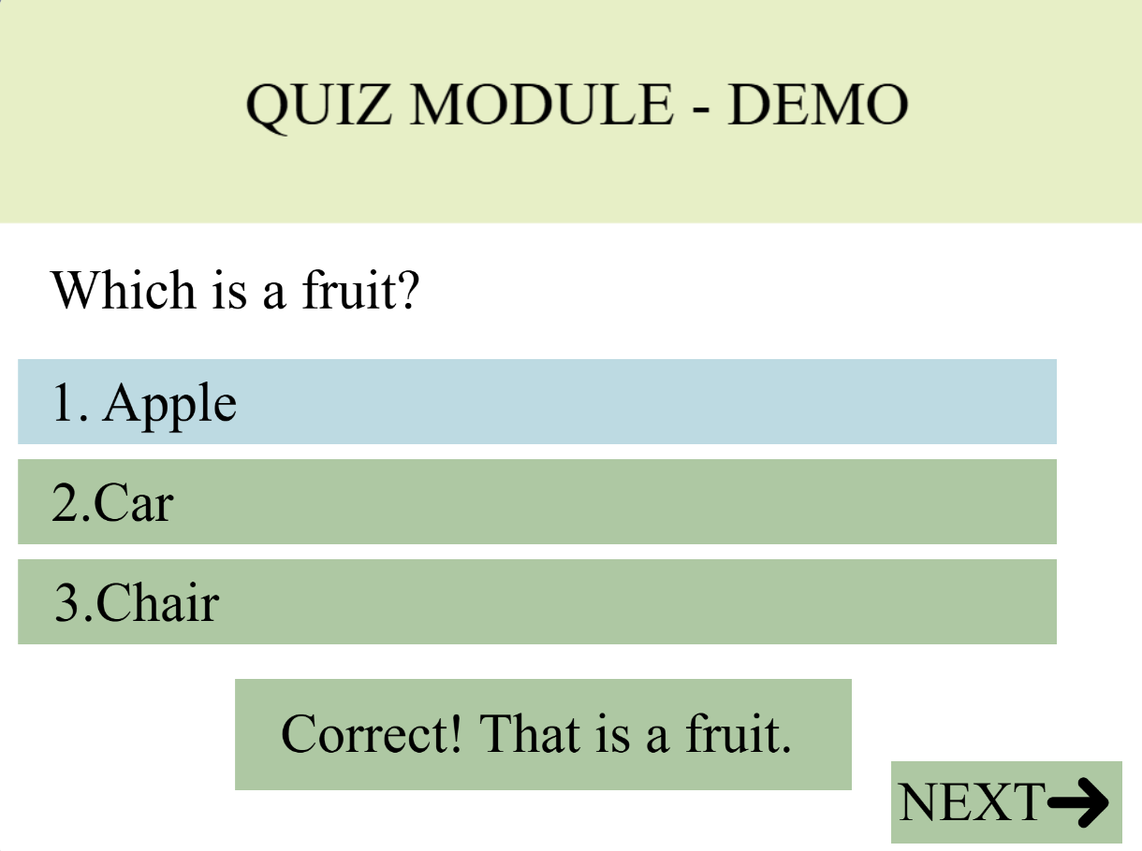

This is part of the demonstration section where when the user clicks on any option, it leads them to a demonstrative view of how the feedback portion of the actual quiz will look like, it will indicate whether the answer is correct (blue) or wrong (red). It will also indicate a short feedback caption below for those who are colourblind.

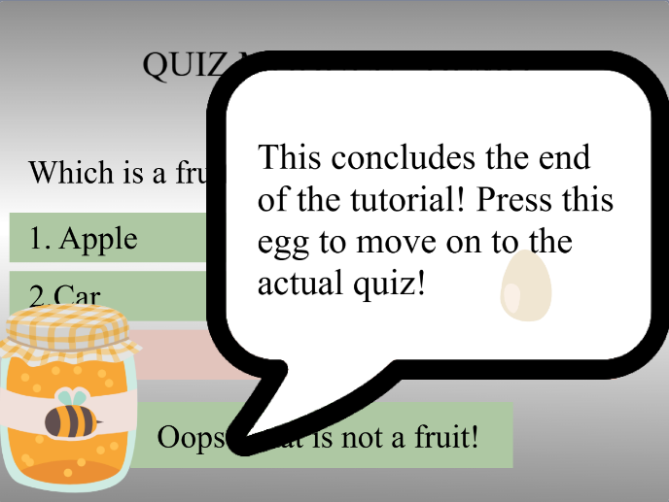

This is part of the demonstration section, after the user clicks on the “Next” Button it will lead to a short narration to conclude the whole narration. However, for the actual quiz, the “Next” Button will lead to the next question.

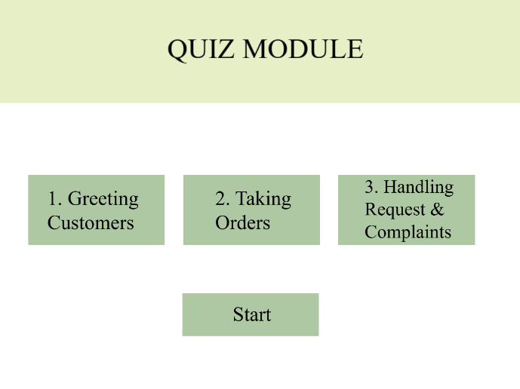

After pressing the egg icon, it will lead users to the actual quiz, the Main Menu, leaving the demonstrative section and entering the main module.

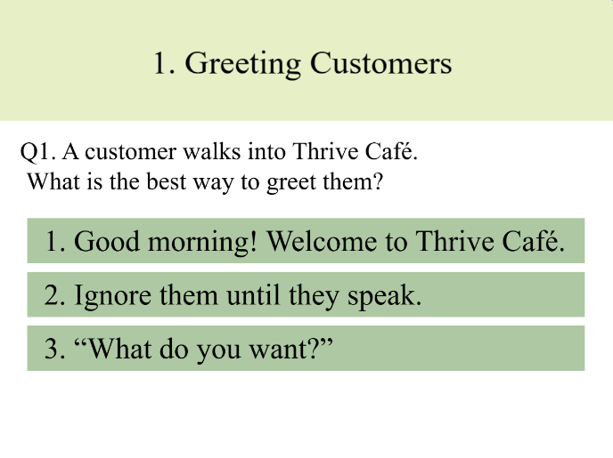

This is where the actual quiz begins, when user clicks on either of the circled buttons, it will lead to their respective corresponding quiz. However, for the start button, it will lead to the first quiz, going in numerical order. The option to select other quiz is to allow users to have the freedom to choose which quiz they like to complete first.

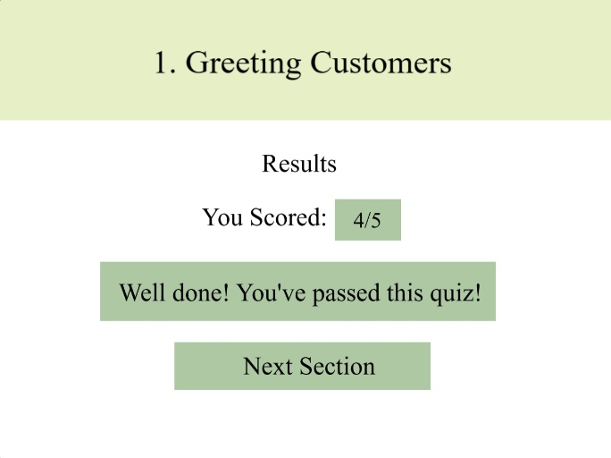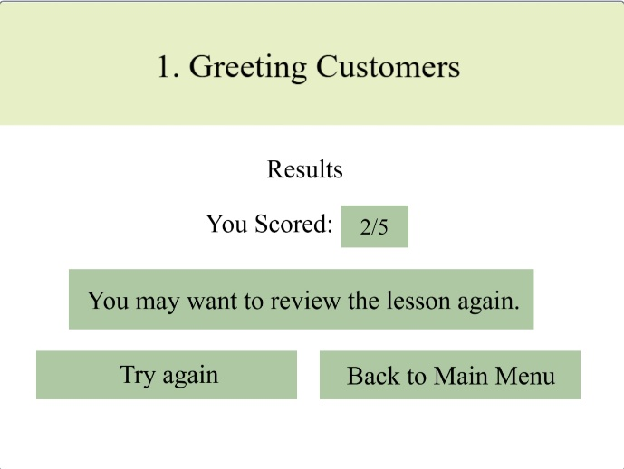

After completing the quiz, it shows the user what score the user obtained, and if the user fails (below 3/5), they have an option to try again the quiz or go back to the Main Menu. However, if the user pass, it will show a next section option, allowing users to move onto the next section.

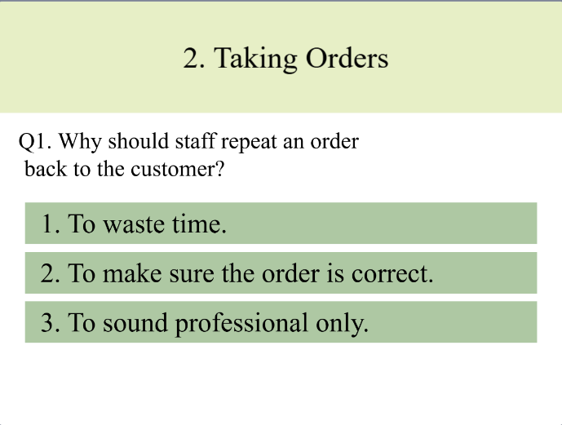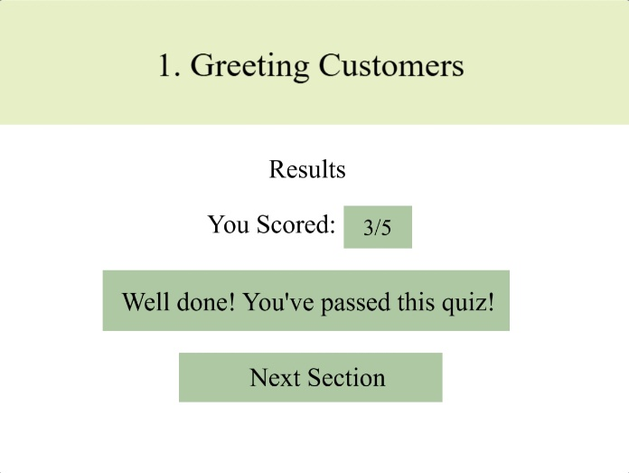

The “Next Section” button leads to the next quiz in numerical order. This saves time, so user does not have to go back to the Main Menu and click the Quiz 2 button.

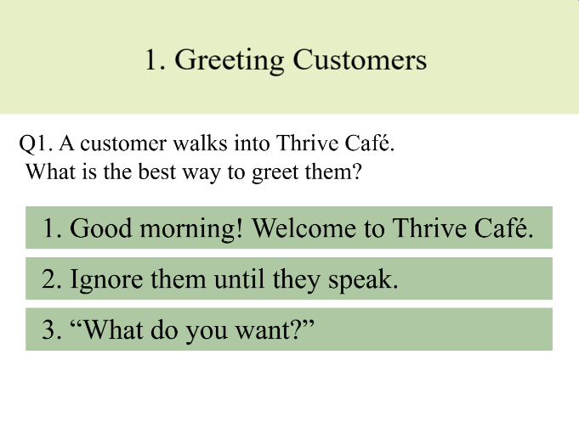



The “Try again” button allows users to redo the quiz, directing the user back to the start of the quiz. While for the “Back to Main Menu” button leads users back to the Main Menu, allowing users to perhaps move on and do other quizzes first.

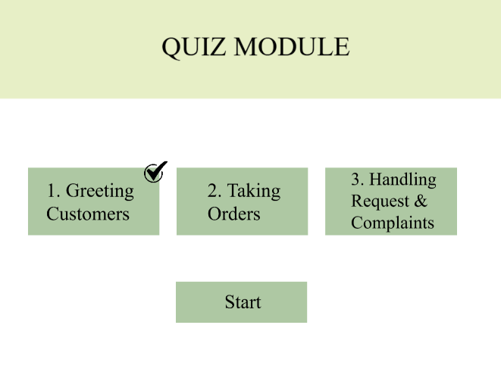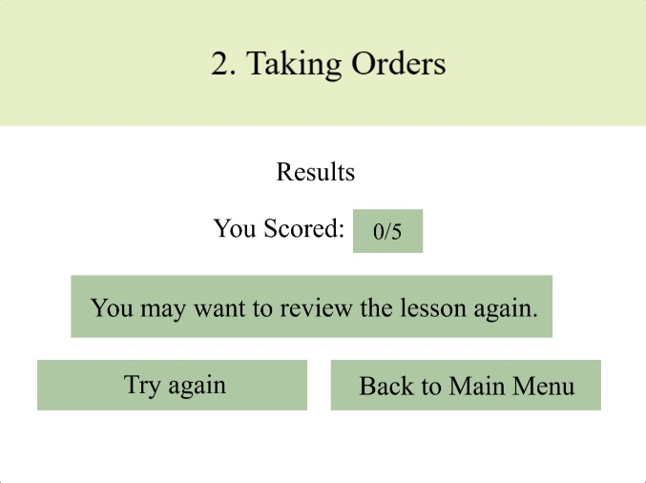

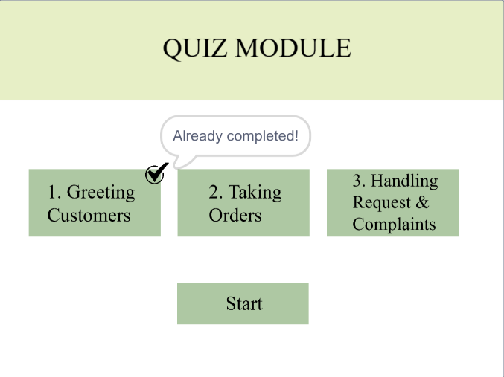

If the user happens to pass the first quiz and fail the second quiz, after the user clicks on the “Back to Main Menu” button, there will be a tick above quiz 1, indicating that the user passed the quiz. And when the user clicks on quiz one, it will say “Already completed!” instead of going into the quiz. This saves the user’s progress.

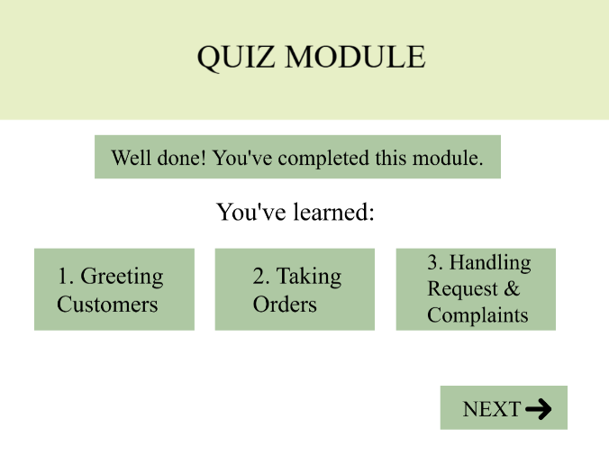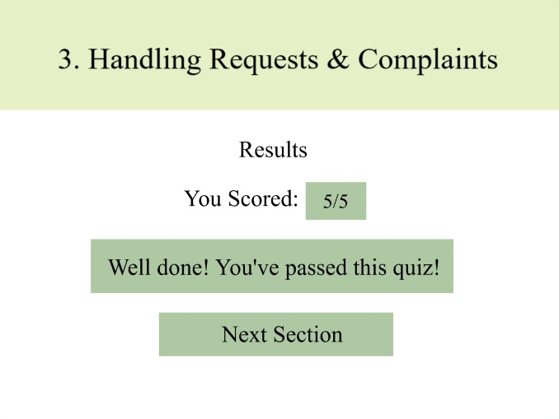

After the user has completed and passed all 3 quizzes, the “Next Section” button will now lead to the end of the quiz. At the end of the quiz, it will show the user all the 3 quizzes they have completed, and a caption on top clearly stating that the user has completed the Quiz Module in case any users get confused. The “Next” button will now lead to another module.

**Story-based Branching (Deva)**

Upon reaching the story-based branching main page users are met with a title at the very top followed with being welcomed into the page. Below the welcome are located the buttons which users can select at random to be led to the respectful story. When user hovers on each story button the button pops out to indicate that the user is hovering over that specific option. After going into one of the stories the next part shows the context of the story. At the bottom right of the context box there is a arrow which upon clicking will lead the user to the story.

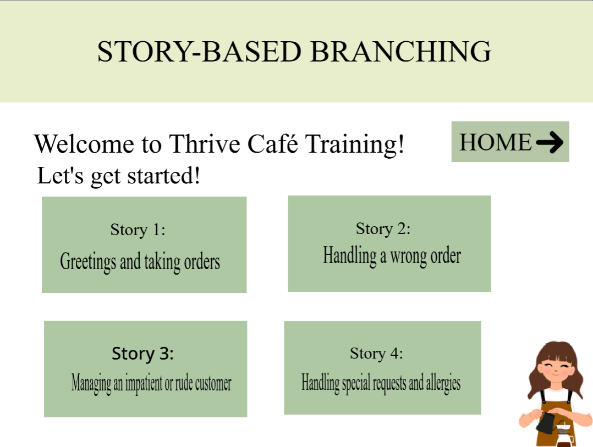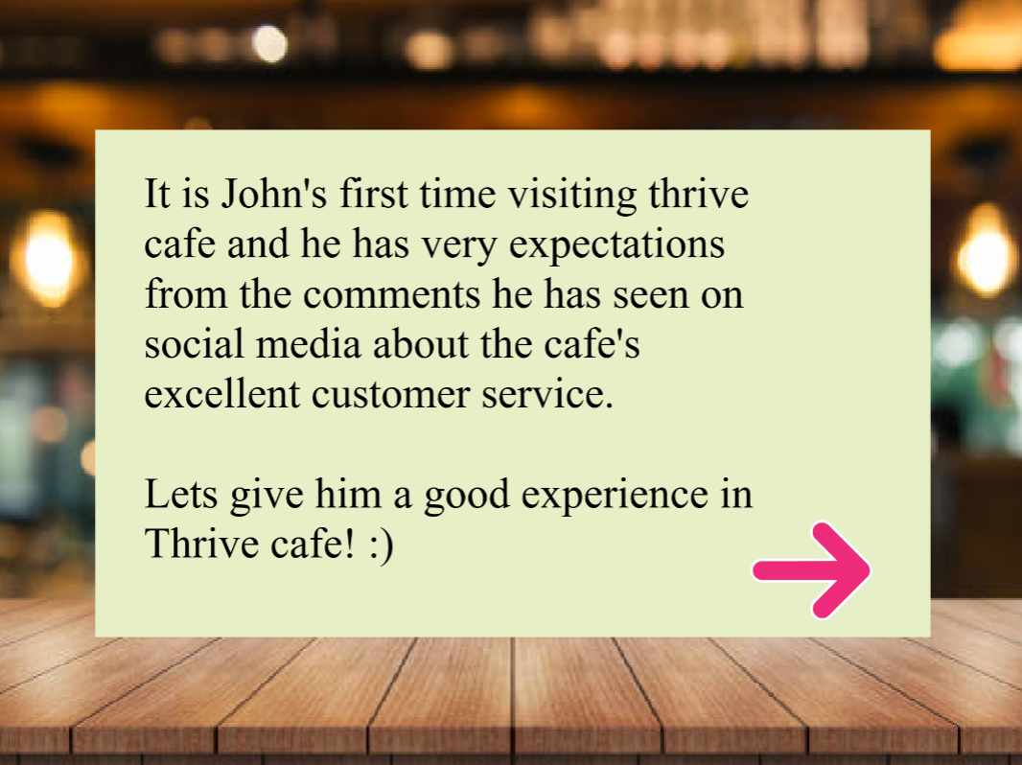

Once the Story starts the user has choose from two options out of which, one is the right answer. Upon hovering on one of the buttons the button will pop up to indicate that the user is hovering over it. When the user clicks the right answer the customer's facial expression looks happier or less annoyed. A tick sign will also appear to indicate to the user that the answer is correct. Thus, customer will reply in a slightly more pleased tone and a next button will appear for user to use to move to next part of the story.

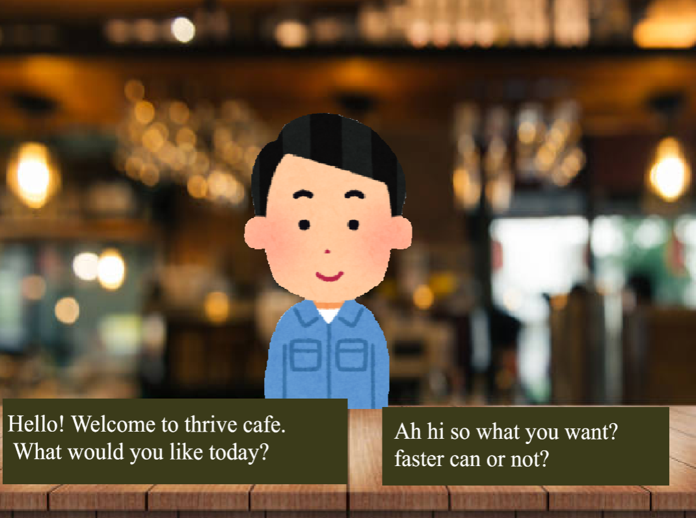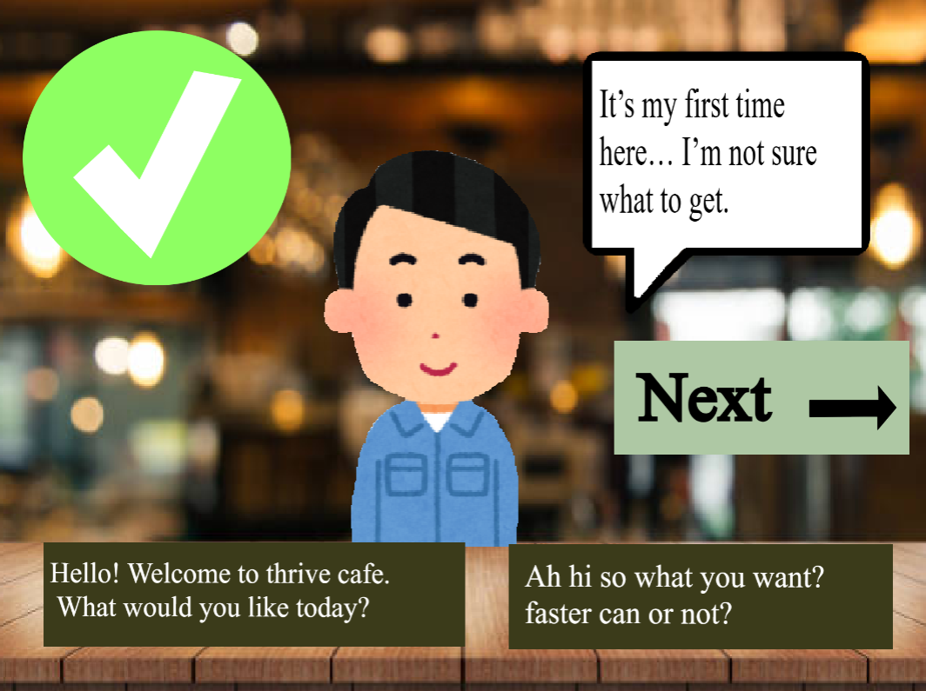

When user clicks on the wrong answer the customer’s facial expression changes into a negative expression. The customer will reply in a negative reply to imply they are mad. A huge cross will appear on the top left corner to indicate the option clicked on is wrong. Upon finishing the story, the user will we brought back to the Story-Based Branching main page from which they can once again choose another story. By clicking the home button on the home page, they are led to the jar page where the user can choose from the variety of modules provided like e-learning, game etc.

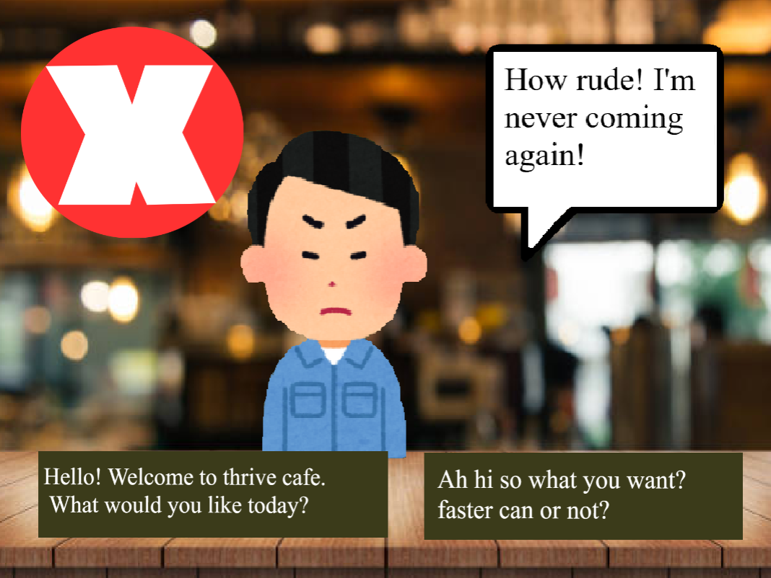

**Discussion**

During discussion, our team came together to make alignments of our ideas and ensure that all components of the project were clearly related and linked. We discuss on the relation and how the overall concept could be effectively applied between to our own modules. We were all allocated with specific roles, spreading the responsibility among the group to ensure clarity and efficiency. Discussing on the required content and outcomes for each section to ensure that our work would be aligned with the project objectives. In addition, the overall aesthetics, which includes our layout, colour scheme, and visual style, are all standardised, ensuring that it is consistent and a professional presentation across all deliverables. By doing so, it helped our team strengthen the coherence of the project and ensured that all parts worked together as a unified solution.

**References**

* Canva. (2026). *Healthy lifestyle infographic* [Infographic]. <https://www.canva.com/>